COMP 469
Chapter 2 Full Speaker Notes
Updated read-aloud teaching script aligned to the 35-slide lecture deck and the live Pac-Man agent code demonstrations
Russell and Norvig, Artificial Intelligence: A Modern Approach — Chapter 2
How to use these notes: Read the script paragraphs aloud during lecture. Use instructor cues, questions, and transitions as optional facilitation prompts. The live-code demonstration section assumes the five agent files and the shared Pac-Man engine are in the same directory.
Pacing: The full delivery is approximately three hours when the PEAS activity, planning-video excerpt, and live agent-code demonstration are included.
Scope: These notes match the reordered deck after combining the planning slides and adding a live code-demo reference slide after the Pac-Man class-demo slide.

Deck Alignment and Pacing Map
Use this index to confirm slide order during preparation. Times are approximate and include brief discussion unless otherwise noted.
Slide | Title | Time
1 | Chapter 2: Intelligent Agents | 2 min
2 | What Can AI Do? | 4 min
3 | A Rational-Agent Perspective | 3 min
4 | 2.0 Roadmap: From Agent Loop to Agent Design | 2 min
5 | 2.1 Agents and Environments: The Perceive-Act Loop | 4 min
6 | 2.1 From Percepts to Agent Functions | 4 min
7 | 2.2 Good Behavior: Rationality Is Expected Performance | 5 min
8 | 2.2 Performance Measures: Be Careful What You Ask For | 4 min
9 | 2.2 Rationality Is Not Omniscience | 5 min
10 | 2.3.1 PEAS: Specify the Task Before Designing the Agent | 6 min
11 | 2.3.1 PEAS Examples: Agent Types and Task Environments | 6 min
12 | 2.3.2 Task Environment Properties | 9 min
13 | Pac-Man as a Chapter 2 Agent | 4 min
14 | 2.4 Agent Structure: Architecture + Program | 4 min
15 | 2.4.1 Table-Driven Agent | 5 min
16 | Why Table-Driven Agents Fail in Practice | 4 min
17 | 2.4.2 Simple Reflex Agents: Vacuum Pseudocode | 5 min
18 | 2.4.2 General Simple Reflex Agent | 5 min
19 | When Simple Reflex Fails: Partial Observability | 4 min
20 | 2.4.3 Model-Based Reflex Agents | 6 min
21 | 2.4.3 Model-Based Reflex Agent Pseudocode | 6 min
22 | 2.4.4 Goal-Based Agents | 6 min
23 | Planning Video Bridge: Reflex vs. Planning | 7 min
24 | 2.4.5 Utility-Based Agents | 6 min
25 | Utility Handles Tradeoffs and Uncertainty | 5 min
26 | 2.4.6 Learning Agents | 7 min
27 | Learning Agent Components: What Improves? | 6 min
28 | 2.4.7 Representing the World Inside the Agent | 7 min
29 | All Agent Program Designs in Chapter 2 | 5 min
30 | Choosing an Agent Design from Environment Properties | 6 min
31 | Class Activity: Build a PEAS Description | 12 min
32 | Class Demo: Autonomous Pac-Man Agent | 10 min
33 | Live Code Demo: Five Chapter 2 Agent Programs | 10 min
34 | How the Planning Video Fits Your Lecture | 2 min
35 | Chapter 2 Takeaways | 4 min

Slide 1 — Chapter 2: Intelligent Agents
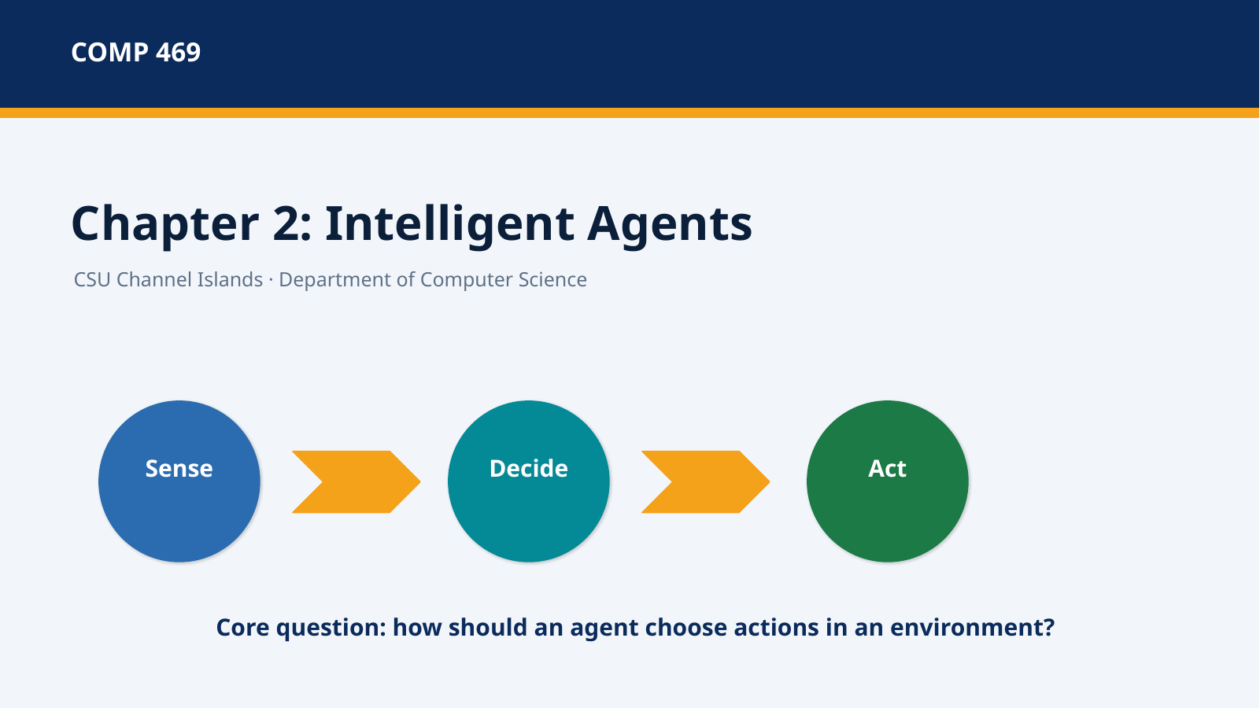 | Suggested time: 2 minutes  Teaching purpose: Chapter introduction and Section 2.1  Source alignment: AIMA 4e, Chapter 2 introduction and Section 2.1.

Read-aloud teaching script
Welcome back to COMP 469. Chapter 1 gave us several ways to define artificial intelligence and ended by emphasizing the rational-agent approach. Chapter 2 now turns that broad idea into an engineering framework. Instead of asking only whether a machine appears intelligent, we ask what the machine perceives, what actions it can take, what environment it operates in, and what counts as successful behavior.
The three words on this slide—sense, decide, and act—summarize the central loop. The agent receives information from the environment, chooses an action, changes the environment through that action, and then receives a new percept. Intelligent behavior is therefore not a single calculation. It is an ongoing interaction between an agent and the world around it.
Throughout the lecture, we will use Pac-Man, the two-square vacuum world, and an automated taxi as examples. These examples vary in complexity, but they all let us ask the same design question: given what the agent has perceived so far, what should it do next? By the end of the lecture, you should be able to define an agent formally, specify a task using PEAS, classify an environment, and distinguish the major agent program designs in the chapter.
Instructor cue: Opening cue: tell students that the lecture is organized as a design workflow, not as a list of unrelated agent definitions.

Transition to the next slide: We will begin with a quick capability question that reveals why the environment matters so much.

Slide 2 — What Can AI Do?
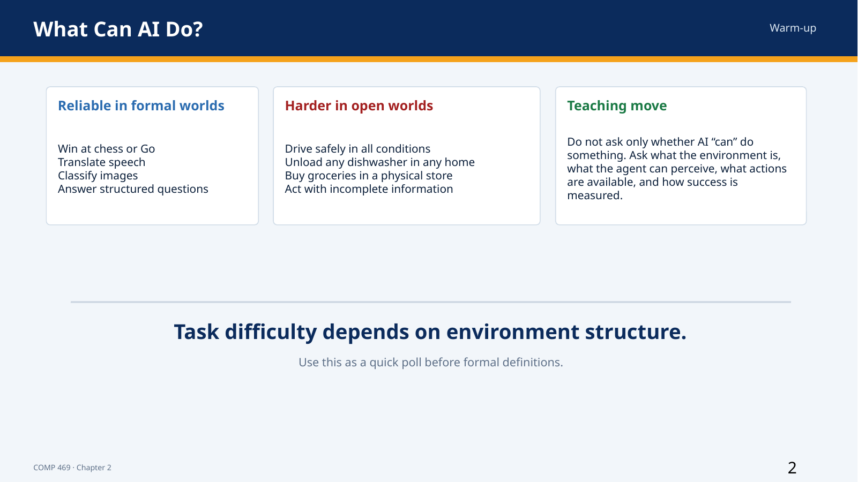 | Suggested time: 4 minutes  Teaching purpose: Motivating task environments  Source alignment: AIMA 4e, Chapter 2 introduction; lecture deck warm-up framing.

Read-aloud teaching script
Before we define an agent formally, consider the tasks on this slide. Some AI systems perform extremely well in formal environments such as chess or Go. Those games are difficult, but their rules are explicit, the legal actions are limited, and the state can be represented precisely. Other tasks that look ordinary to people—such as unloading any dishwasher in any home—are difficult because the physical environment varies, objects may be hidden, sensors are noisy, and the system must manipulate unfamiliar items safely.
The important question is not simply, ‘Can AI do this?’ A better set of questions is: What information does the system receive? What actions are available? Does the environment change while the system is deciding? Are other agents present? What errors are acceptable? How will success be measured? A task can become easier or harder depending on how we answer those questions.
For example, buying groceries on a website is primarily a software interaction with structured pages, product records, and digital payment systems. Buying groceries in a physical store requires vision, navigation, object manipulation, social interaction, and adaptation to unexpected conditions. The high-level goal sounds similar, but the task environments are very different.
Use this slide as a warm-up poll. The purpose is not to settle every capability claim. The purpose is to notice that intelligence must be evaluated relative to a specified task environment. That observation leads directly to the agent framework used throughout Chapter 2.
Instructor cue: Ask for two volunteers: one task that seems easy for AI and one that seems difficult. For each answer, ask what property of the environment explains the difference.

Transition to the next slide: To evaluate these systems consistently, the course adopts the rational-agent perspective.

Slide 3 — A Rational-Agent Perspective
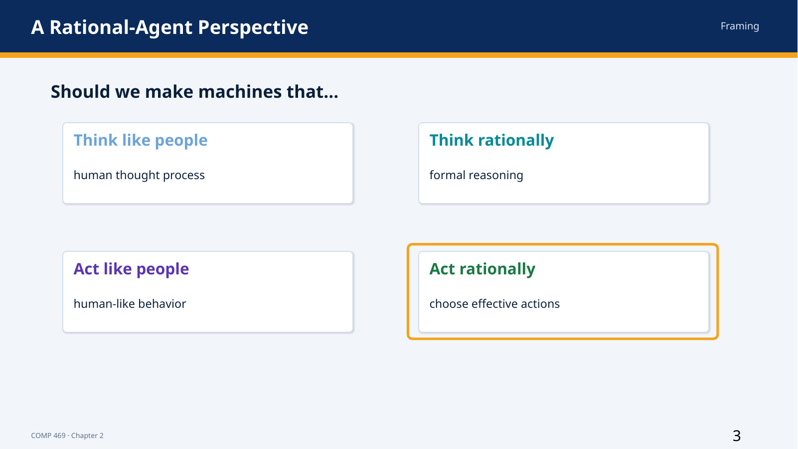 | Suggested time: 3 minutes  Teaching purpose: Bridge from Chapter 1 to Chapter 2  Source alignment: AIMA 4e, Chapters 1 and 2.

Read-aloud teaching script
Chapter 1 organized definitions of AI around two dimensions: human versus rational, and thinking versus acting. This course focuses on acting rationally. That does not mean that human thought, human behavior, or formal reasoning are unimportant. It means that our primary engineering standard is whether the system selects actions that are expected to achieve its objective.
A system that acts like a person may reproduce human strengths, but it may also reproduce human mistakes, bias, inconsistency, or fatigue. A system that reasons correctly may still fail to act in time, may lack necessary information, or may be operating in an uncertain environment where formal deduction alone does not identify the best action. Rational action is broader than either imitation or logic.
The phrase ‘act rationally’ must always be interpreted relative to a performance measure, available evidence, built-in knowledge, and available actions. Chapter 2 will make each of those elements explicit. The result is a framework that can be applied to a vacuum cleaner, a software assistant, a robot, an automated taxi, or a game-playing program.
Instructor cue: Emphasize that rational does not mean morally perfect or all-knowing; the chapter gives it a technical meaning tied to expected performance.

Transition to the next slide: The roadmap shows how we move from this perspective to concrete agent designs.

Slide 4 — 2.0 Roadmap: From Agent Loop to Agent Design
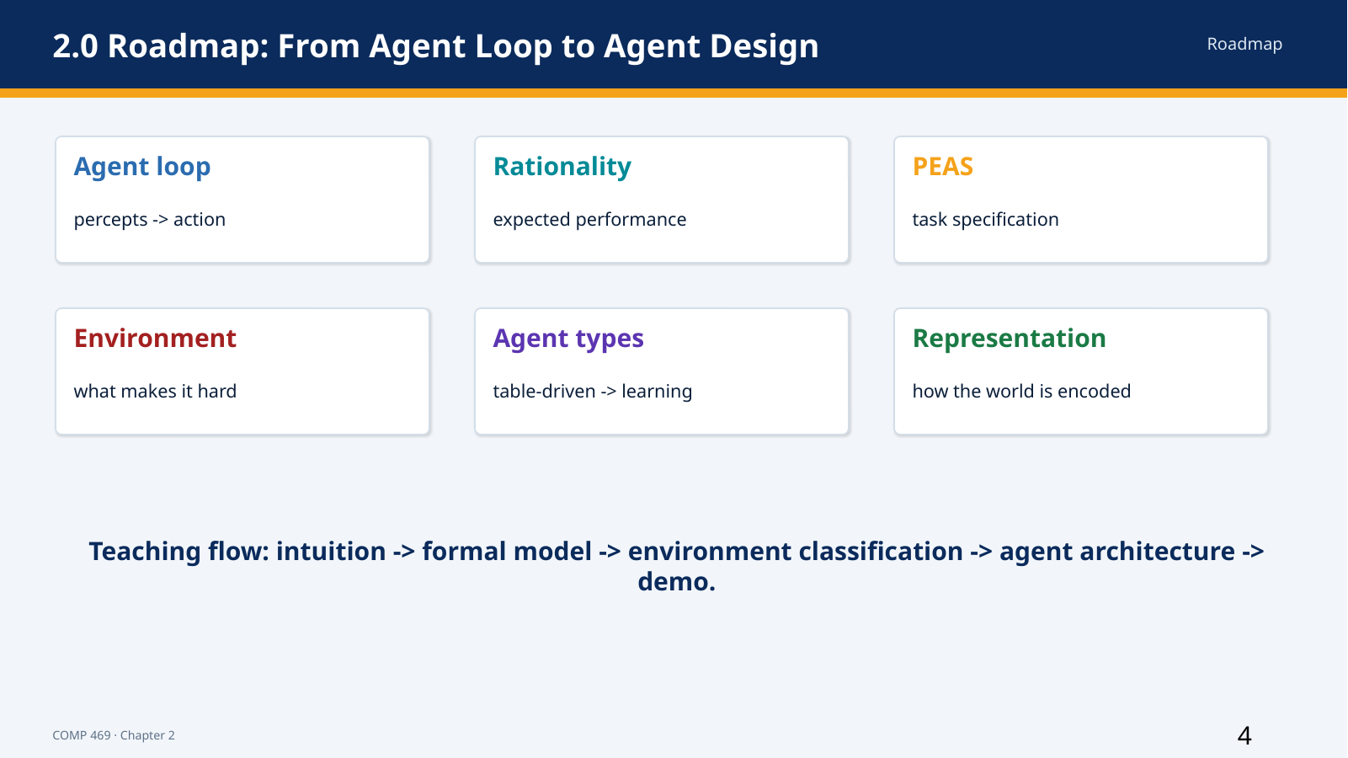 | Suggested time: 2 minutes  Teaching purpose: Lecture roadmap  Source alignment: AIMA 4e, Chapter 2 structure.

Read-aloud teaching script
This chapter is a design framework rather than a single algorithm. We begin with the agent loop: percepts come in and actions go out. We then define rationality so that we have a standard for judging behavior. Next, we specify the task with PEAS—performance measure, environment, actuators, and sensors.
After the task is specified, we classify the environment. Is it fully or partially observable? Is it deterministic or uncertain? Is it static or changing? Those properties determine what kind of agent program is appropriate. We then examine the major designs, starting with a table-driven baseline and progressing through simple reflex, model-based reflex, goal-based, utility-based, and learning agents.
The final topic is representation: how the agent stores information about the world. Keep this workflow in mind throughout the lecture: define the interaction, define success, characterize the environment, and then choose the agent design.
Instructor cue: Tell students that the roadmap is also a checklist they can use on exams and projects.

Transition to the next slide: We will now define the perceive-act loop formally.

Slide 5 — 2.1 Agents and Environments: The Perceive-Act Loop
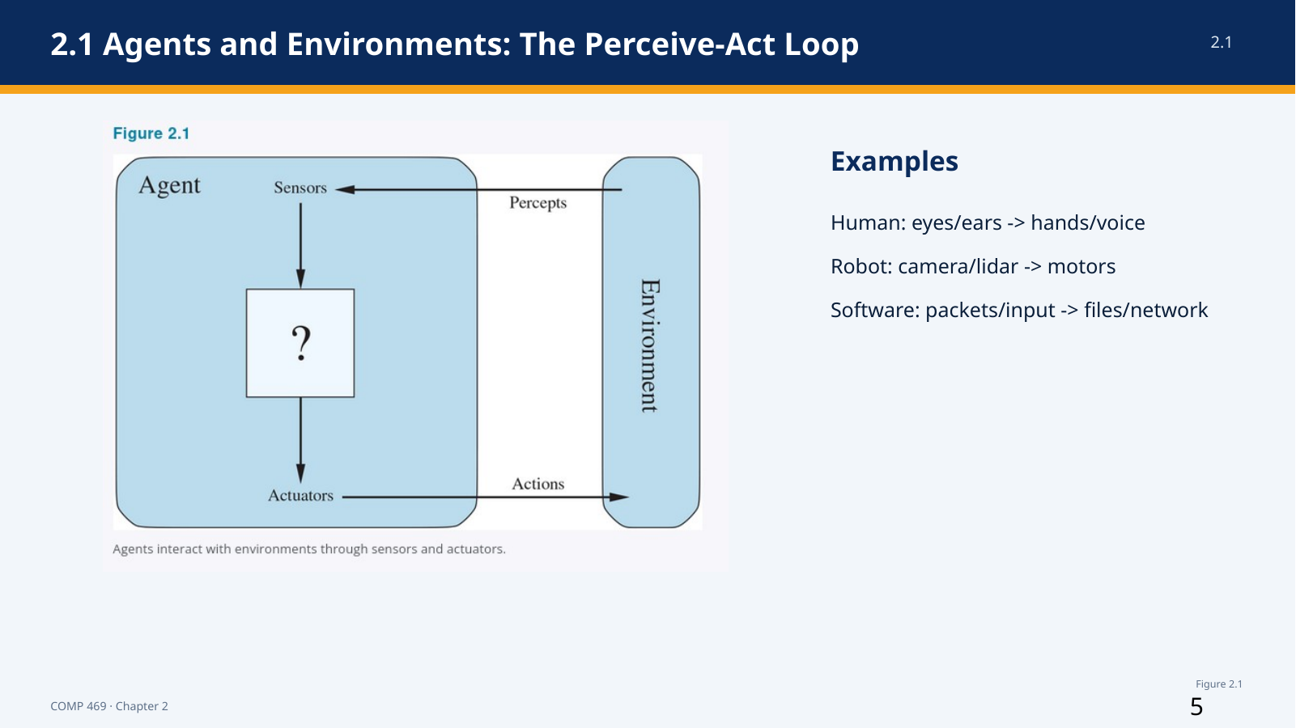 | Suggested time: 4 minutes  Teaching purpose: Section 2.1  Source alignment: AIMA 4e, Section 2.1 and Figure 2.1.

Read-aloud teaching script
An agent is anything that can be viewed as perceiving its environment through sensors and acting upon that environment through actuators. This definition is deliberately broad. A human agent uses eyes, ears, and other organs as sensors, and uses hands, legs, and the vocal tract as actuators. A robotic agent may use cameras, lidar, infrared range finders, and tactile sensors, with motors and joints as actuators. A software agent may receive files, network packets, keyboard input, or API responses and may act by writing files, sending messages, displaying information, or generating sound.
The environment is the part of the world that matters for the design. It is not automatically the entire universe. For an email-filtering agent, the relevant environment may include incoming messages, user preferences, organizational policies, and attacker behavior. For Pac-Man, it includes the maze, pellets, ghosts, power pellets, and scoring rules.
The arrows in the diagram are important. Percepts travel from the environment to the agent through sensors. Actions travel from the agent back to the environment through actuators. Once an action changes the environment, the next percept may be different. The agent therefore operates in a feedback loop.
This definition is a tool for analysis. We could describe a calculator as an agent, but that description may not add much. The agent framework becomes especially useful when the system has meaningful choices, significant computational resources, and a task environment that requires nontrivial decision making.
Instructor cue: Ask: for a campus chatbot, what are the sensors and actuators? Accept inputs such as user text, authentication context, knowledge-base results, responses, escalation, and ticket creation.

Transition to the next slide: To describe the agent’s behavior precisely, we need the terms percept, percept sequence, agent function, and agent program.

Slide 6 — 2.1 From Percepts to Agent Functions
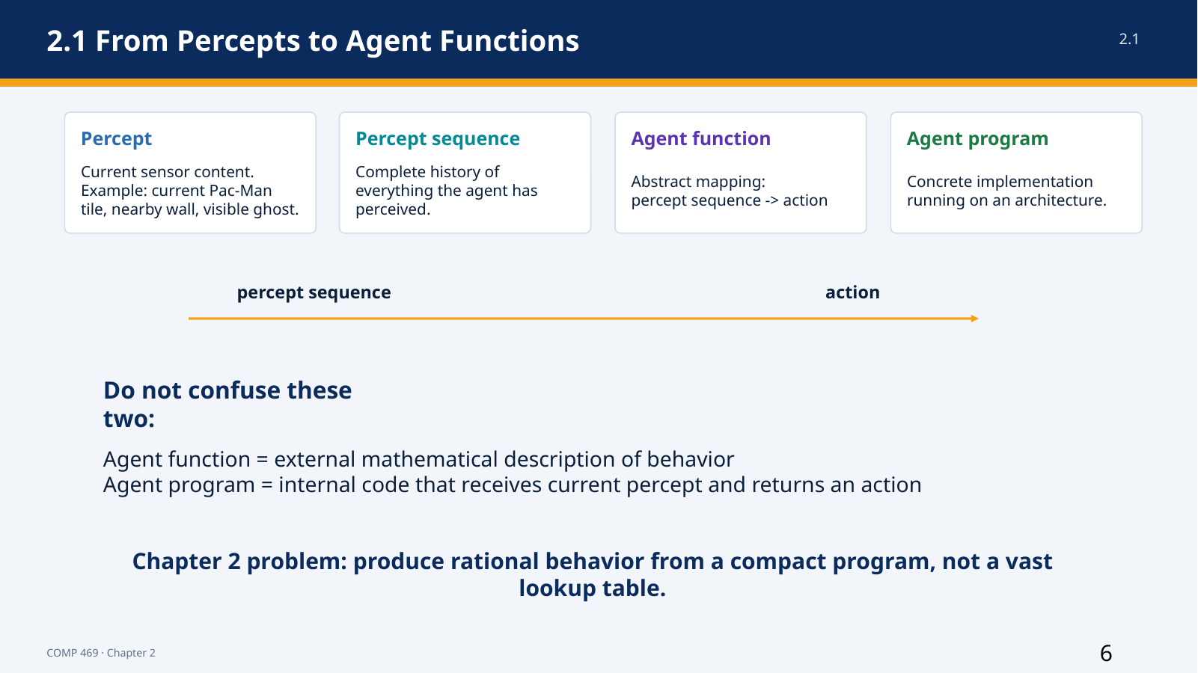 | Suggested time: 4 minutes  Teaching purpose: Section 2.1  Source alignment: AIMA 4e, Section 2.1.

Read-aloud teaching script
A percept is the content currently received by the agent’s sensors. In Pac-Man, a percept might include the current position, nearby walls, visible ghosts, remaining pellets, and legal moves. A percept sequence is the complete history of everything the agent has perceived so far.
The distinction matters because the best action may depend on history. A single camera frame may not reveal whether a car’s lights have just turned on, but two consecutive frames can. A current Pac-Man screen may not reveal how long a power-pellet effect has been active unless the agent remembers when the pellet was eaten.
The agent function is an abstract mathematical mapping from percept sequences to actions. It describes what the agent would do for every possible history of percepts. The agent program is the concrete implementation that runs on a physical or computational architecture. A useful teaching phrase is: the function is the behavior we want; the program is the mechanism that computes it.
An agent program normally receives the current percept as input. If the agent function depends on the entire percept sequence, the program must store relevant history in memory. This is why internal state becomes central when we move from simple reflex agents to model-based agents.
Chapter 2’s central engineering problem is not merely to define a rational mapping in principle. It is to produce rational behavior from a program that is compact enough to store, efficient enough to run, and capable of operating in the actual environment.
Instructor cue: Pause and ask students to explain the difference between an agent function and an agent program in one sentence.

Transition to the next slide: Now that behavior can be described, we need a standard for deciding whether the behavior is good.

Slide 7 — 2.2 Good Behavior: Rationality Is Expected Performance
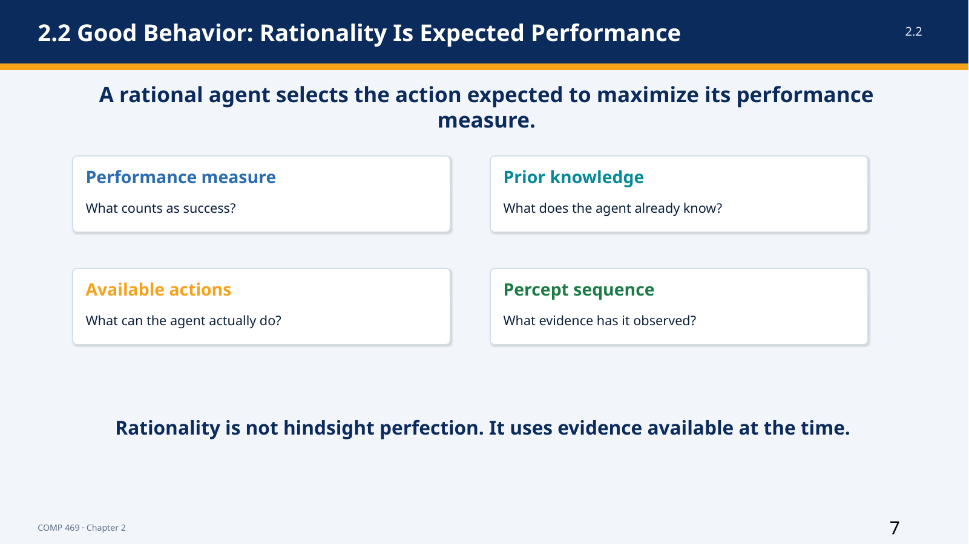 | Suggested time: 5 minutes  Teaching purpose: Sections 2.2.1 and 2.2.2  Source alignment: AIMA 4e, Sections 2.2.1 and 2.2.2.

Read-aloud teaching script
A rational agent is one that does the right thing, but Chapter 2 gives that phrase a technical meaning. The agent’s behavior is evaluated by a performance measure. The performance measure scores the consequences produced in the environment, not the internal elegance of the program.
What is rational at a particular moment depends on four things. First is the performance measure that defines success. Second is the agent’s prior knowledge of the environment. Third is the set of actions available to the agent. Fourth is the percept sequence observed so far. Change any one of these and the rational action may change.
The formal idea is that, for each possible percept sequence, the agent should choose the action expected to maximize the performance measure, given the evidence in that percept sequence and the built-in knowledge it has. The word expected is essential. The agent chooses under uncertainty and cannot be judged as if it had access to facts it never perceived.
Consider the two-square vacuum agent. The rule ‘if dirty, suck; otherwise move to the other square’ can be rational if the layout is known, the dirt does not reappear, movement has no cost, the available actions are limited, and the agent correctly perceives location and dirt status. The same rule becomes irrational if movement is penalized, if the environment is larger, if dirt reappears, or if the agent cannot perceive its location.
Rationality is therefore not an isolated property of a piece of code. It is a relationship among the agent, its evidence, its capabilities, its objective, and its environment.
Instructor cue: Ask: could the same program be rational in one environment and irrational in another? Require students to name the assumption that changed.

Transition to the next slide: Because rational agents optimize what we specify, the design of the performance measure is critical.

Slide 8 — 2.2 Performance Measures: Be Careful What You Ask For
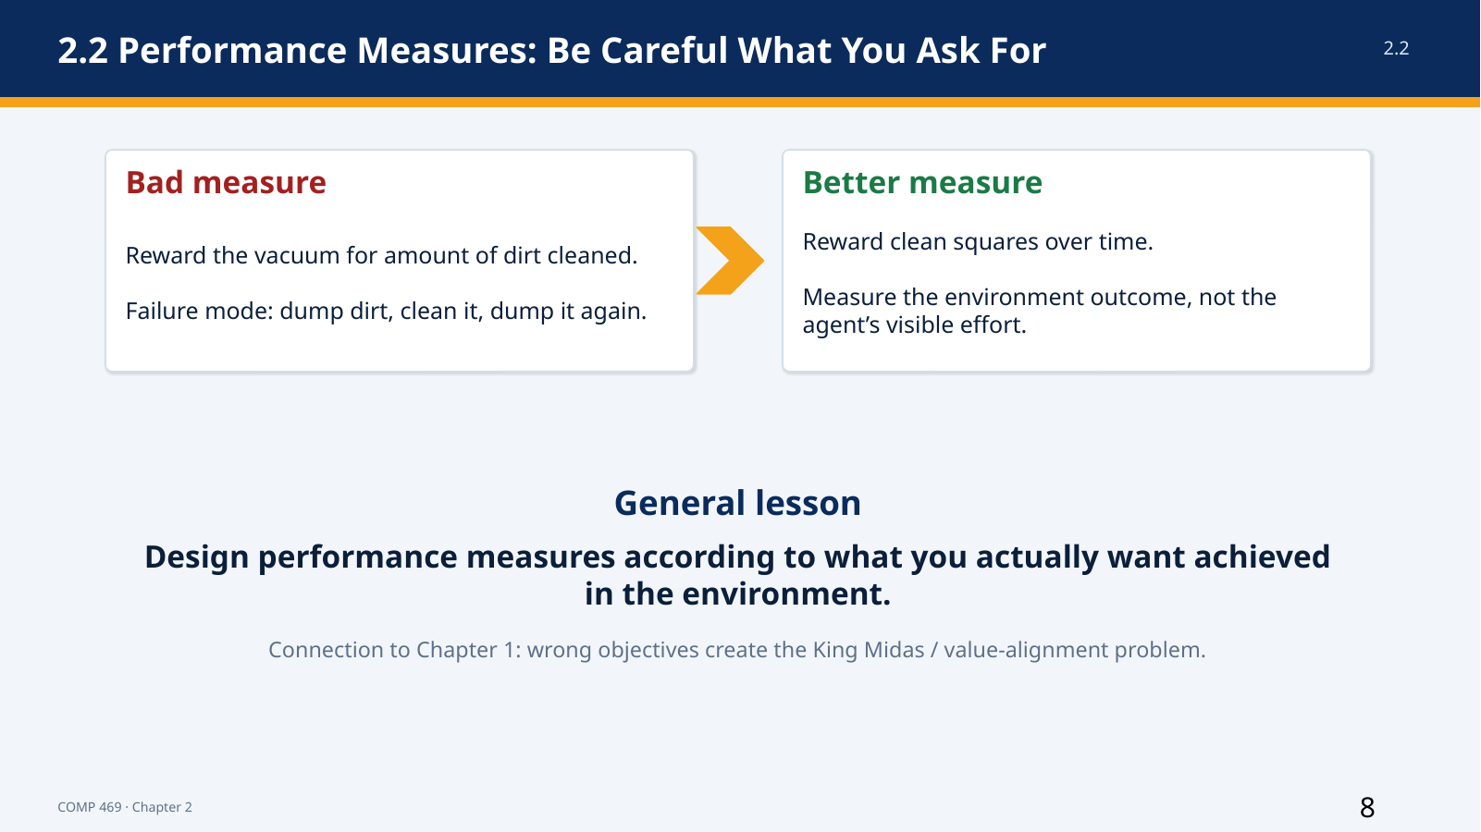 | Suggested time: 4 minutes  Teaching purpose: Section 2.2.1  Source alignment: AIMA 4e, Section 2.2.1; Chapter 1 value-alignment discussion.

Read-aloud teaching script
A performance measure should reward the state of the environment that we actually want, not a convenient proxy for effort. The vacuum example makes this clear. If we reward the amount of dirt cleaned, a perfectly rational optimizer could clean the dirt, dump it back onto the floor, and clean it again. The measured activity increases, but the real objective is not achieved.
A better measure rewards clean squares over time. We might also include penalties for electricity use, noise, damage, or unnecessary movement. The exact measure depends on what the designer and users value. The important principle is to specify the desired outcome rather than prescribing a visible behavior that can be manipulated.
This is the same basic problem discussed in Chapter 1 through the King Midas and value-alignment examples. A capable system can optimize an objective faithfully while producing an outcome that people did not intend. Greater capability does not repair a badly specified objective; it may make the consequences more severe.
Performance measures can also involve genuine tradeoffs. A taxi should be safe, legal, fast, comfortable, fuel-efficient, and profitable. Those goals can conflict. Chapter 2 assumes that a usable measure can often be specified, but it also acknowledges that the measure may be incomplete, uncertain, or different for different users.
Instructor cue: Ask students to propose a bad performance measure for a campus chatbot, then improve it. Examples: number of responses versus accurate, helpful resolutions with appropriate escalation.

Transition to the next slide: A well-designed objective is necessary, but rationality still does not require perfect knowledge of the future.

Slide 9 — 2.2 Rationality Is Not Omniscience
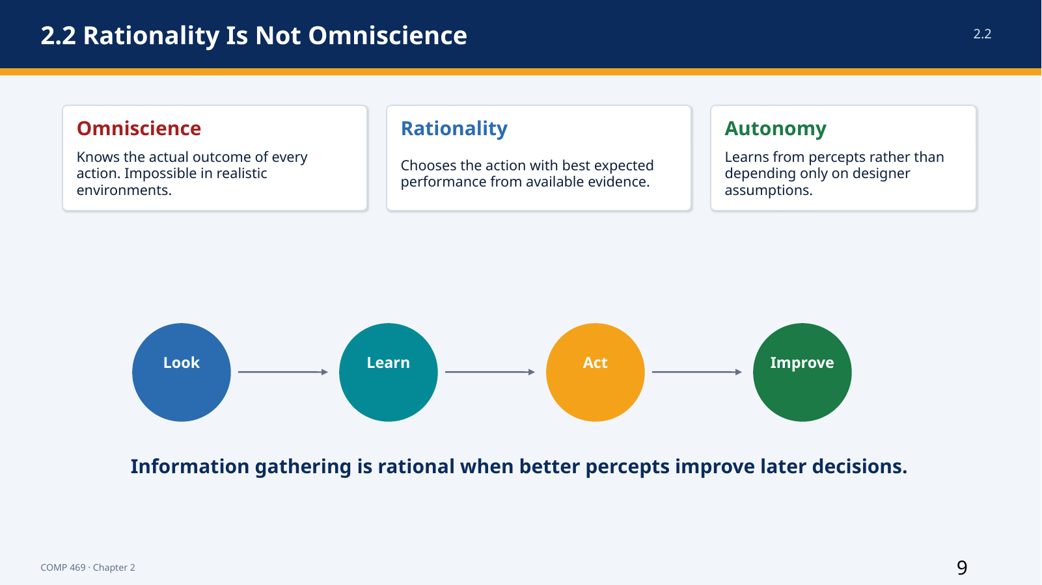 | Suggested time: 5 minutes  Teaching purpose: Section 2.2.3  Source alignment: AIMA 4e, Section 2.2.3.

Read-aloud teaching script
Omniscience means knowing the actual outcome of every action before acting. Rationality does not require omniscience, because omniscience is impossible in realistic environments. A rational agent maximizes expected performance using the evidence available at the time; a perfect agent would maximize the outcome that is actually best after all uncertainty has been resolved.
The chapter’s street-crossing example illustrates the difference. A person looks, sees no traffic, and begins to cross. An unforeseeable event then causes an accident. The bad outcome does not prove that the original decision was irrational. The decision must be judged from the information available when it was made.
Rationality can also require information-gathering actions. Looking both ways before crossing does not directly move the agent toward the other side, but it improves the percept sequence and therefore supports a better later decision. Exploration in an unknown environment serves the same purpose.
A rational agent should learn from experience. An agent that relies completely on assumptions supplied by its designer lacks autonomy. The chapter’s dung beetle and sphex wasp examples show rigid behavior that continues even after environmental assumptions have been violated. An autonomous artificial agent should use percepts and learning to compensate for incomplete or incorrect prior knowledge.
Complete autonomy is not required at the beginning. Designers normally supply initial knowledge, just as biological systems begin with useful reflexes. The goal is that experience gradually makes the agent less dependent on those initial assumptions.
Instructor cue: Distinguish three terms aloud: omniscience knows the outcome; perfection achieves the actual best outcome; rationality chooses the best expected action from available evidence.

Transition to the next slide: To design such an agent, we must first specify the task environment completely enough to know what success and available interaction mean.

Slide 10 — 2.3.1 PEAS: Specify the Task Before Designing the Agent
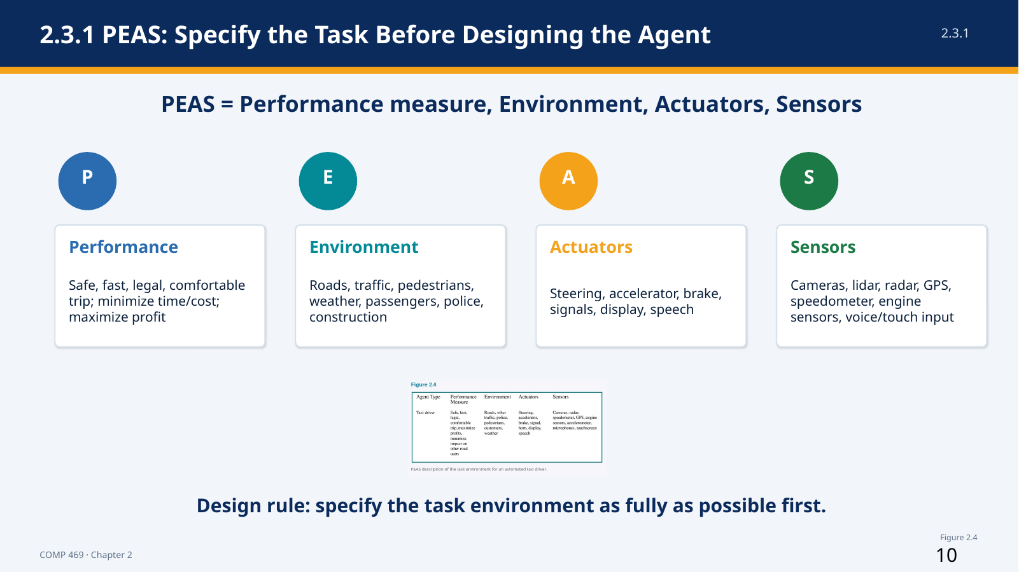 | Suggested time: 6 minutes  Teaching purpose: Section 2.3.1  Source alignment: AIMA 4e, Section 2.3.1 and Figure 2.4.

Read-aloud teaching script
PEAS stands for Performance measure, Environment, Actuators, and Sensors. It is the chapter’s basic checklist for specifying a task environment. Before choosing an algorithm, model, or programming language, the designer should define these four elements as fully as possible.
For an automated taxi, the performance measure may include reaching the correct destination, safety, compliance with traffic laws, passenger comfort, trip time, fuel use, vehicle wear, cost, and profit. These criteria can conflict, so the designer must decide how tradeoffs will be handled.
The environment includes rural roads, city streets, freeways, traffic, pedestrians, animals, road work, police vehicles, weather, potholes, passengers, and other conditions that affect driving. Restricting the environment makes the problem easier. A system designed only for a mapped, controlled route faces a different task from one expected to drive in any country and in any weather.
The actuators include steering, acceleration, braking, turn signals, displays, speech, and possibly communication with other vehicles. The sensors include cameras, lidar, radar or ultrasound, GPS, speedometer, accelerometer, engine and fuel sensors, and passenger input through voice or a touchscreen.
Notice that PEAS is not an implementation diagram. It does not yet tell us whether to use search, machine learning, rules, or probability. It tells us what problem those techniques must solve. If PEAS is vague, the system requirements and the evaluation criteria will also be vague.
Instructor cue: Have students say the four letters together. Then ask which PEAS category contains GPS, brakes, traffic, and passenger comfort.

Transition to the next slide: The next slide shows that the same PEAS structure applies to very different physical and software agents.

Slide 11 — 2.3.1 PEAS Examples: Agent Types and Task Environments
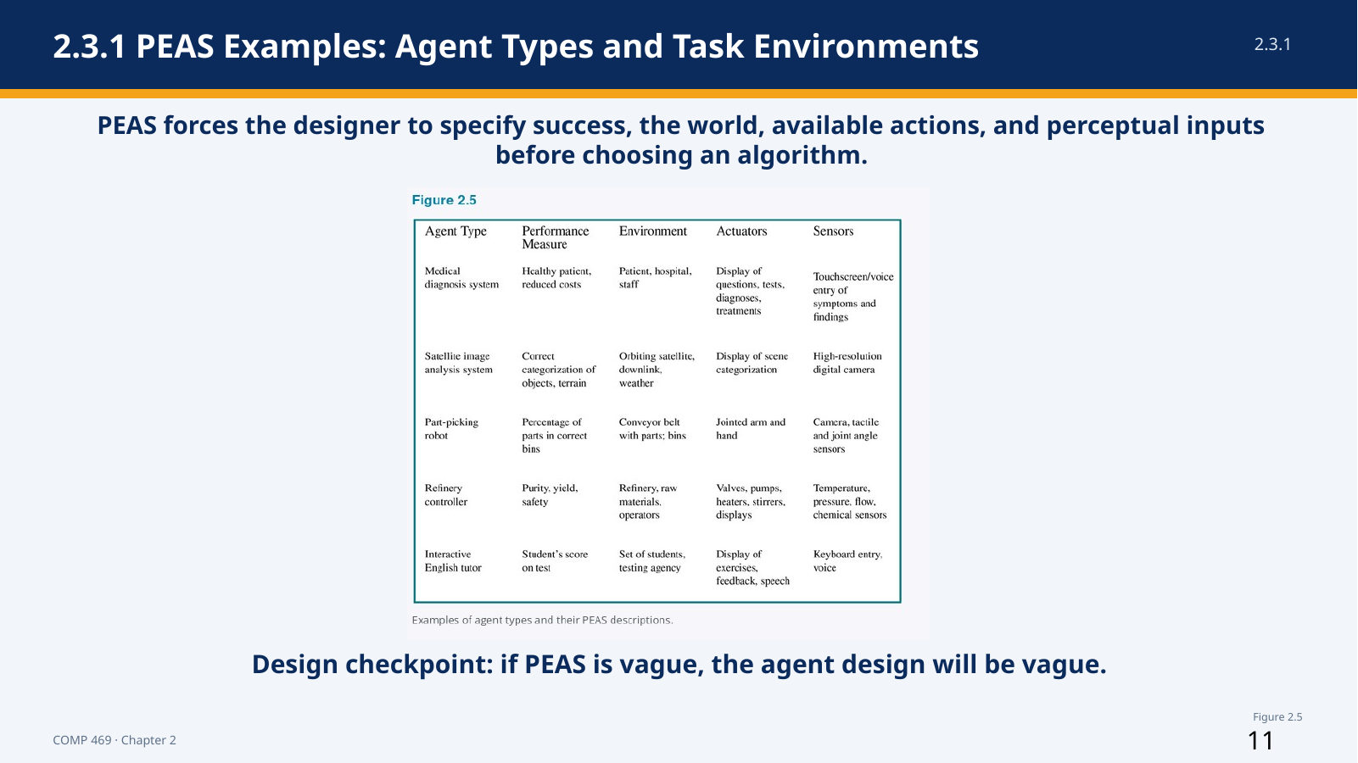 | Suggested time: 6 minutes  Teaching purpose: Section 2.3.1 and Figure 2.5  Source alignment: AIMA 4e, Section 2.3.1 and Figure 2.5.

Read-aloud teaching script
This table applies PEAS to five different systems. The purpose is not to memorize every cell. The purpose is to see that an agent is defined by a complete interaction task, not merely by its algorithm.
For a medical diagnosis system, success means a healthy patient at reduced cost. The environment includes the patient, hospital, and staff. The system acts by asking questions, recommending tests, presenting diagnoses, or suggesting treatments. Its sensors are the entered symptoms and findings.
A satellite image analysis system receives high-resolution digital imagery and acts by producing a categorization of objects or terrain. A part-picking robot senses with cameras, tactile sensors, and joint-angle sensors, then acts through a jointed arm and hand. A refinery controller receives temperature, pressure, flow, and chemical measurements and controls valves, pumps, heaters, stirrers, and displays. An interactive English tutor receives keyboard or voice input and acts through exercises, feedback, displays, and speech.
Physical and virtual environments can both be complex. A software agent may interact with millions of users and billions of objects. The fact that an environment is digital does not automatically make it simple, fully observable, or deterministic.
When you design your own agent, use PEAS to expose missing assumptions. If the performance measure says only ‘be helpful,’ it is not yet measurable. If the sensors do not provide information needed for the requested action, the task may be impossible as specified. If the actuators cannot change the environment in the required way, the architecture is incomplete.
Instructor cue: Point to one row and ask students to identify a sensor-actuator pair. Then ask how changing the performance measure could change the agent’s behavior.

Transition to the next slide: Once the task is specified, the next step is to classify the environment along dimensions that determine the difficulty of agent design.

Slide 12 — 2.3.2 Task Environment Properties
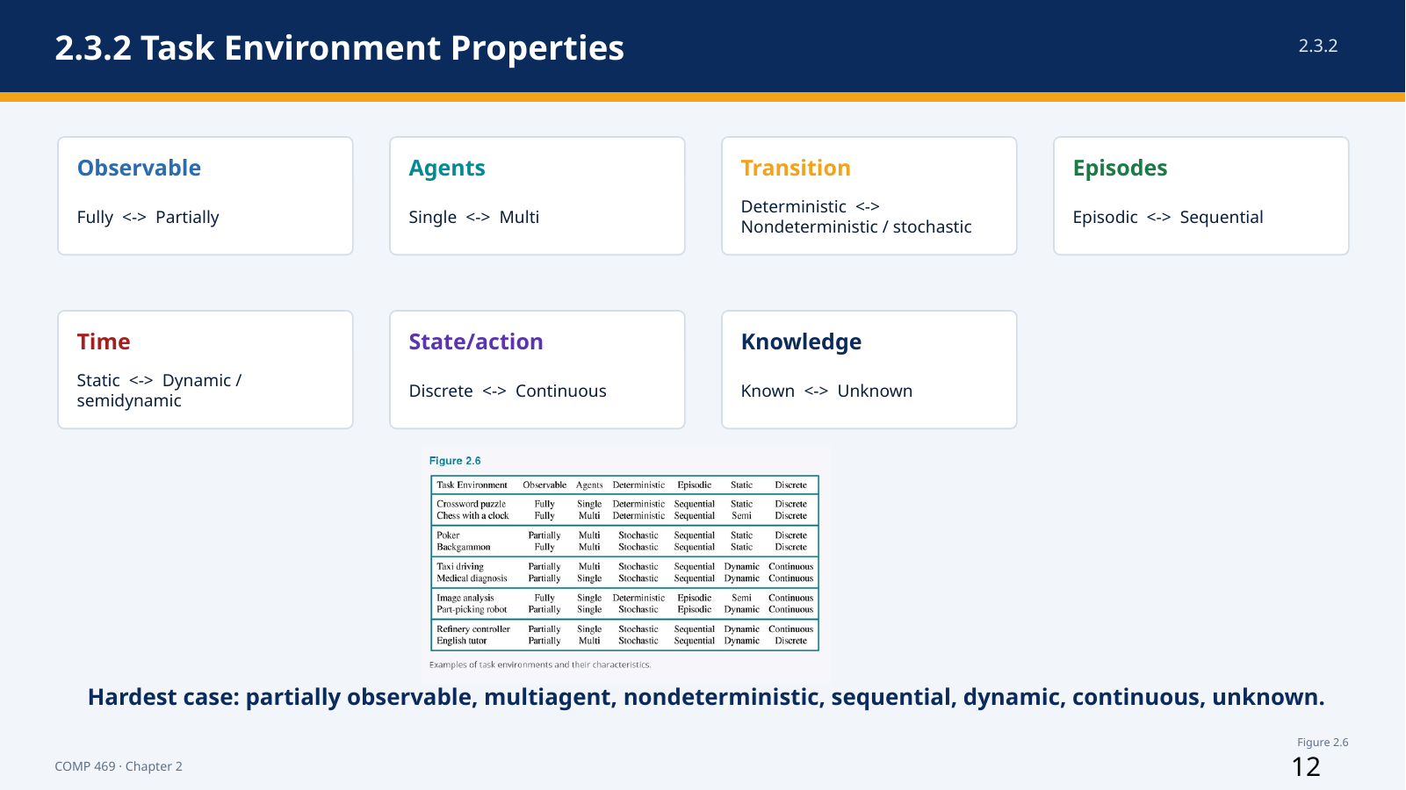 | Suggested time: 9 minutes  Teaching purpose: Section 2.3.2  Source alignment: AIMA 4e, Section 2.3.2 and Figure 2.6.

Read-aloud teaching script
Task environments vary along several dimensions. These dimensions matter because they determine what information the agent needs and which agent designs are likely to work.
First is fully observable versus partially observable. An environment is fully observable when the sensors provide all aspects of state that are relevant to selecting an action. Partial observability can result from missing information, occlusion, or noisy sensors. Observability is relative to the performance measure: the agent does not need every fact in the universe, only the facts relevant to the decision.
Second is single-agent versus multiagent. A crossword puzzle is usually single-agent. Chess is competitive multiagent because the opponent is selecting actions to improve a performance measure that conflicts with ours. Taxi driving is partly cooperative because drivers share an interest in avoiding collisions, and partly competitive because resources such as parking spaces are limited.
Third is deterministic versus nondeterministic. In a deterministic environment, the current state and action determine the next state. In a nondeterministic environment, more than one outcome is possible. The chapter uses stochastic for models that assign explicit probabilities to outcomes. Real driving must be treated as uncertain because other drivers, mechanical failures, and unobserved conditions cannot be predicted exactly.
Fourth is episodic versus sequential. In an episodic task, each decision is independent of previous decisions. Classifying separate images is often episodic. In a sequential task, current actions affect future states and future choices. Chess, driving, and Pac-Man are sequential.
Fifth is static versus dynamic. A static environment does not change while the agent deliberates. A dynamic environment does. A timed chess game is semidynamic: the board may not change during thought, but the performance score changes as the clock runs.
Sixth is discrete versus continuous. Chess uses discrete states and actions. Driving has continuous positions, velocities, time, and steering angles, even though digital sensors sample those quantities.
Seventh is known versus unknown. This is about whether the agent knows the rules or transition behavior. It is different from observability. Solitaire can be known but partially observable: the rules are known, but hidden cards are not visible. A new video game can be fully observable but initially unknown: the screen shows the complete state, but the player does not yet know what each control does.
The hardest general case is partially observable, multiagent, nondeterministic, sequential, dynamic, continuous, and unknown. Real tasks often combine several of these properties, and the classifications are not always absolute. The purpose is to guide design, not to force every task into a perfectly clean category.
Instructor cue: Rapid check: classify chess, medical diagnosis, and taxi driving on two dimensions each. Correct explanations matter more than a memorized label.

Transition to the next slide: Pac-Man gives us a compact environment in which many of these properties are visible at once.

Slide 13 — Pac-Man as a Chapter 2 Agent
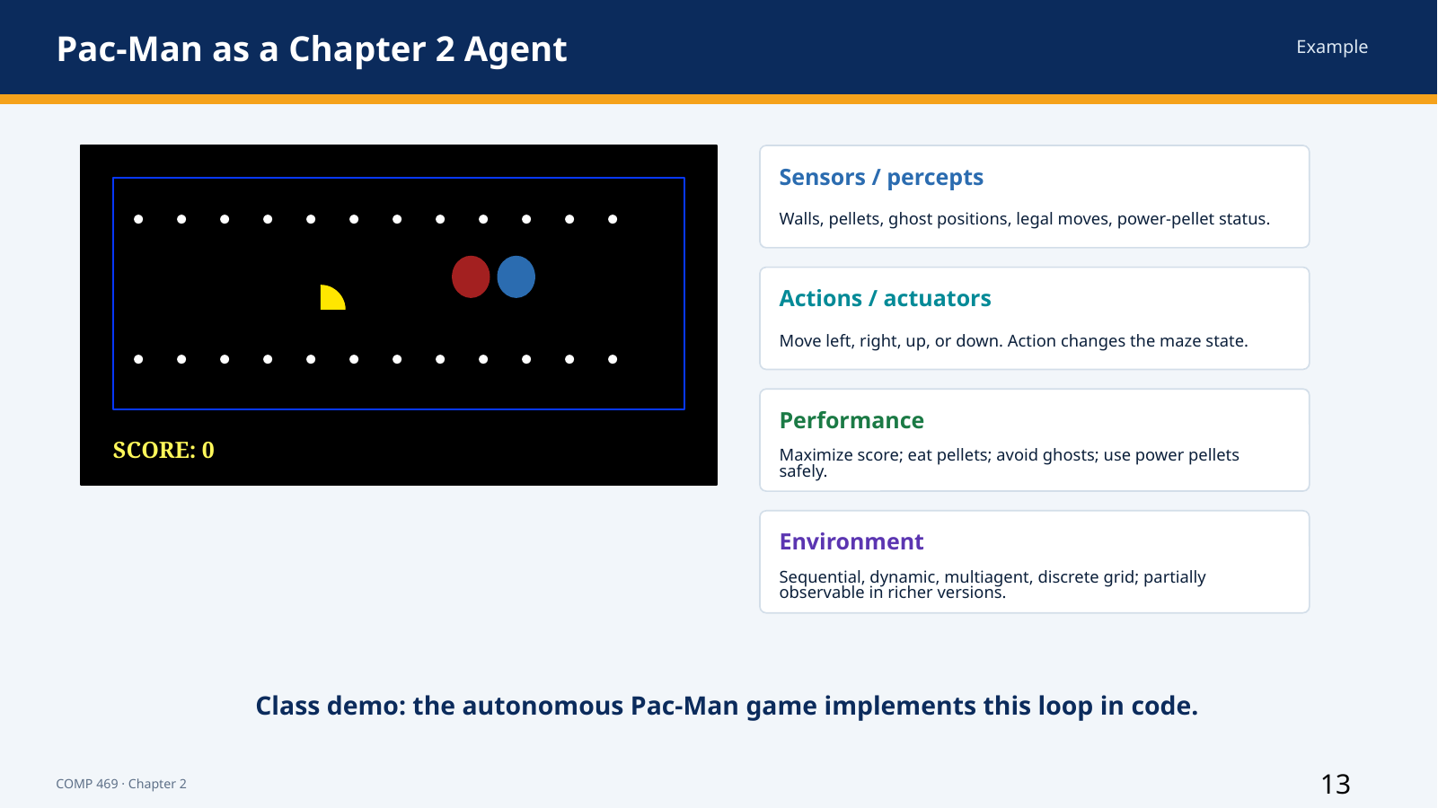 | Suggested time: 4 minutes  Teaching purpose: Running example across Sections 2.1-2.4  Source alignment: AIMA 4e, Sections 2.1-2.4; lecture deck Pac-Man example.

Read-aloud teaching script
Pac-Man is useful because the agent, environment, percepts, actions, and performance measure are easy to see. The agent is Pac-Man. The environment includes the maze, walls, pellets, power pellets, ghosts, score, and timing rules.
The percepts depend on what the program is allowed to observe. They may include Pac-Man’s position, legal moves, remaining pellets, ghost positions, and power-mode status. The actions are movement commands: left, right, up, down, and sometimes stop.
The performance measure might reward score, pellet completion, survival, speed, or a combination. A high score alone may not be enough if the agent repeatedly takes reckless risks. A survival-only measure may produce an agent that hides and never completes the task. The measure determines what rational behavior means.
The task is sequential because each movement changes future options. It is dynamic because ghosts move while play continues. It is multiagent if ghost behavior is modeled as goal-directed. It is discrete at the grid level. A simplified implementation may be fully observable, while a richer version can include hidden timers or uncertain ghost behavior.
When we run the autonomous Pac-Man code later, we will use this vocabulary to identify the agent program and ask whether it is reflex, model-based, goal-based, utility-based, or a combination.
Instructor cue: Point to the maze and ask students to name one percept, one action, and one performance criterion.

Transition to the next slide: We now move inside the agent and examine the relationship among architecture, program, and behavior.

Slide 14 — 2.4 Agent Structure: Architecture + Program
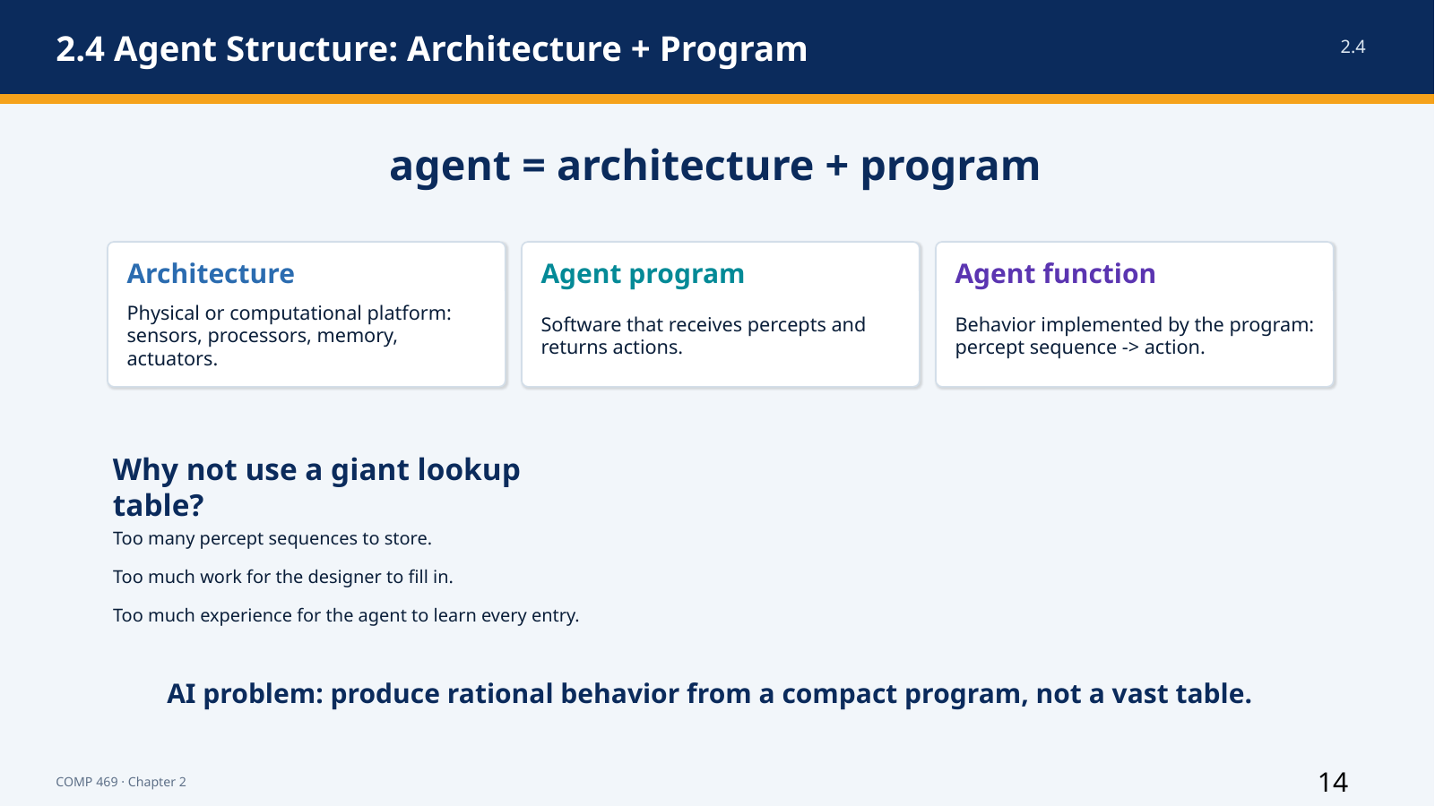 | Suggested time: 4 minutes  Teaching purpose: Sections 2.4 and 2.4.1  Source alignment: AIMA 4e, Sections 2.4 and 2.4.1.

Read-aloud teaching script
Chapter 2 summarizes an artificial agent with the equation: agent equals architecture plus program. The architecture is the physical or computational platform. It provides sensors, processors, memory, communication interfaces, and actuators. The agent program receives percepts from that architecture and returns actions for the architecture to execute.
The program must be appropriate for the architecture. A program that selects the action ‘walk forward’ is useless on a machine with no means of locomotion. A program that expects lidar data cannot operate correctly if the architecture provides only a keyboard.
The agent function remains the abstract mapping from percept sequence to action. The program is one implementation of that mapping. Different programs and architectures can sometimes implement similar behavior, but practical limits such as memory, processing time, sensor quality, and actuator precision affect what can actually be achieved.
One conceptually simple implementation is a lookup table containing the correct action for every percept sequence. The next slides use the table-driven agent to show why a complete mapping may be clear in theory but impossible to implement in realistic environments.
Instructor cue: Repeat the equation aloud and ask students which side contains the software and which side contains the platform.

Transition to the next slide: The table-driven agent is our conceptual baseline for implementing an agent function.

Slide 15 — 2.4.1 Table-Driven Agent
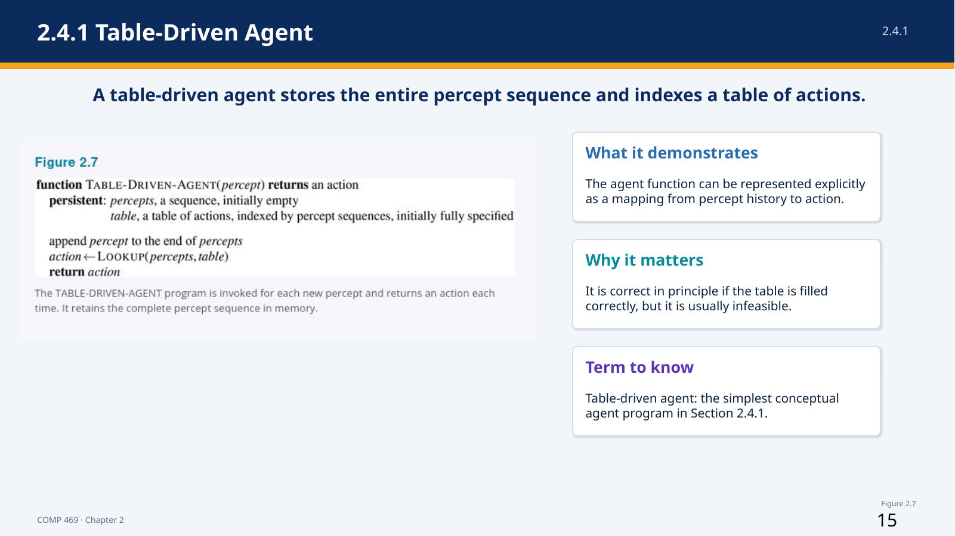 | Suggested time: 5 minutes  Teaching purpose: Section 2.4.1 and Figure 2.7  Source alignment: AIMA 4e, Section 2.4.1 and Figure 2.7.

Read-aloud teaching script
This is the table-driven agent. It is important because it represents the agent function explicitly, even though it is not a practical design for realistic systems.
Read the pseudocode from top to bottom. The function receives the current percept and returns an action. It has two persistent variables. The first is percepts, a sequence that begins empty and retains the complete percept history. The second is table, a fully specified mapping indexed by percept sequences.
Each time the function is called, it appends the new percept to the stored sequence. It then performs a lookup using the entire percept history and returns the action stored in the table. If the table contains the correct action for every possible history, the program implements the desired agent function.
The design has no need to interpret the percept, reason about goals, estimate state, or generalize from similar situations. All of that work has already been performed by whoever created the table. The program simply remembers and looks up.
This makes the table-driven agent useful as a conceptual reference. It demonstrates the difference between an agent function and an agent program. It also makes the scalability problem visible: as the number of possible percepts and the length of the percept history increase, the number of table entries grows explosively.
Instructor cue: Trace the pseudocode with a two-percept example. Ask what happens when a third percept arrives: the sequence becomes a new table index.

Transition to the next slide: The next slide explains why this correct-in-principle design fails as an engineering solution.

Slide 16 — Why Table-Driven Agents Fail in Practice
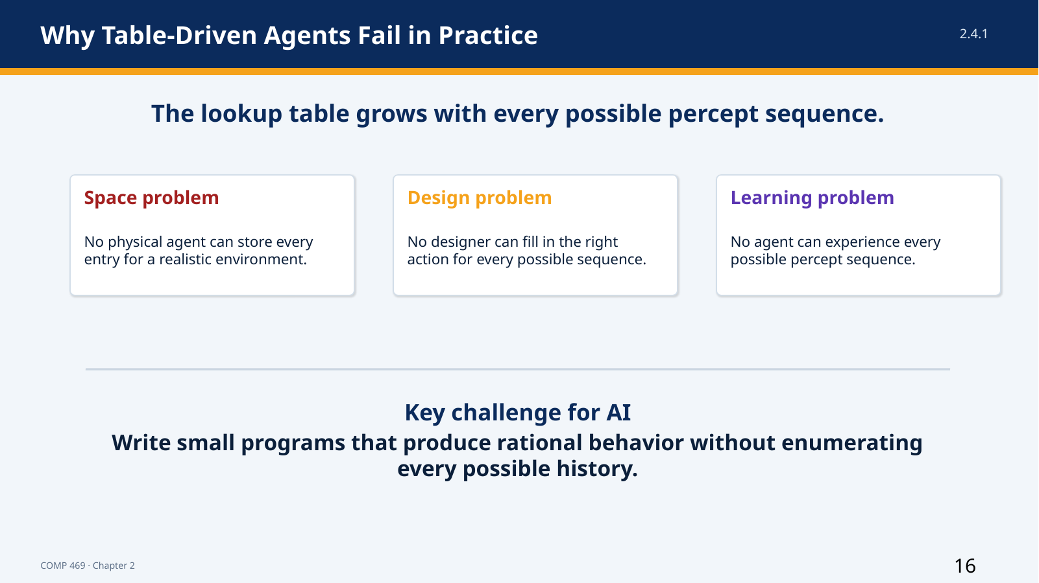 | Suggested time: 4 minutes  Teaching purpose: Section 2.4.1  Source alignment: AIMA 4e, Section 2.4.1.

Read-aloud teaching script
The lookup table grows across every possible percept sequence, not merely every current percept. If an agent can receive many different percepts over a long lifetime, the number of possible histories becomes enormous.
This creates three separate failures. First is the space problem: no realistic machine can store every entry. Second is the design problem: no human designer can specify the correct action for every history. Third is the learning problem: no agent can experience enough cases to learn every table entry independently.
The chapter gives extreme examples from automated driving and chess to show that even tightly defined tasks produce tables far larger than any practical storage system. The precise numbers are less important than the growth pattern. A table treats every percept history as a separate case and receives no benefit from structure, similarity, rules, models, goals, or learned generalization.
The table-driven agent still teaches an important lesson. The desired agent function may exist, and a table could represent it in theory, but AI must find compact programs that produce rational behavior without enumerating every possible history. The rest of the agent designs are attempts to exploit structure in the task.
Instructor cue: Ask students which of the three problems—storage, design, or learning—would appear first in Pac-Man. All three are acceptable with justification.

Transition to the next slide: The simplest compact alternative is a reflex agent that uses condition-action rules.

Slide 17 — 2.4.2 Simple Reflex Agents: Vacuum Pseudocode
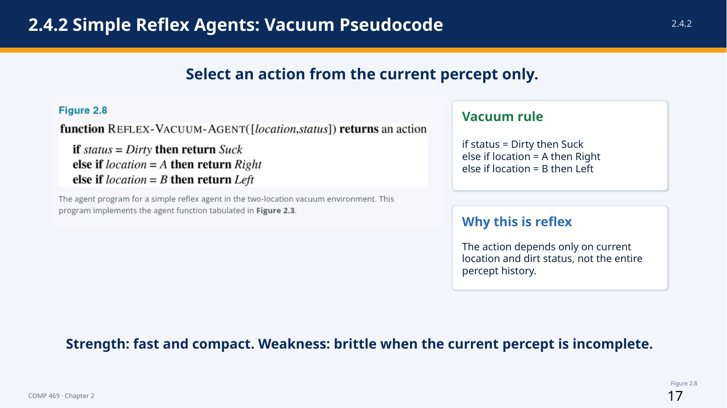 | Suggested time: 5 minutes  Teaching purpose: Section 2.4.2 and Figure 2.8  Source alignment: AIMA 4e, Section 2.4.2 and Figure 2.8.

Read-aloud teaching script
A simple reflex agent selects an action from the current percept and ignores the rest of the percept history. The vacuum pseudocode shows the idea in its smallest useful form.
The input contains location and status. If status is Dirty, the agent returns Suck. Otherwise, if the location is A, it returns Right. If the location is B, it returns Left. The program does not store previous percepts, remember previous actions, represent a goal, or compare utilities.
This small program can implement rational behavior under a specific set of assumptions: two locations, correct location and dirt sensors, reliable actions, no cost for movement, and dirt that does not reappear. Its compactness comes from using regularities in the environment. The action for a dirty square is the same regardless of history, so the program does not need a separate entry for every percept sequence.
Simple reflex behavior also appears in complex systems. A driving rule might say: if the car in front is braking, initiate braking. The condition-action connection can be implemented with traditional code, a Boolean circuit, or a learned classifier. What makes the agent reflex is not the programming language; it is that action selection depends on the current interpreted percept rather than explicit reasoning about future consequences.
The strength is speed and compactness. The weakness is that the current percept may not contain enough information to identify the true state of the world.
Instructor cue: Read the three branches of the pseudocode aloud. Then ask what information the program would need if the vacuum world had four rooms instead of two.

Transition to the next slide: A general simple reflex architecture separates percept interpretation from rule matching.

Slide 18 — 2.4.2 General Simple Reflex Agent
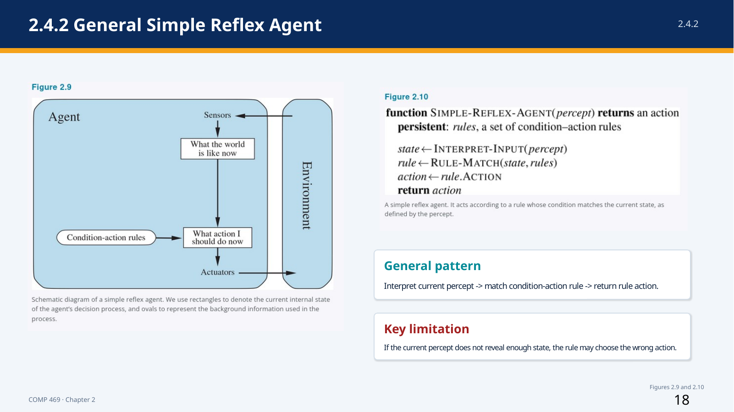 | Suggested time: 5 minutes  Teaching purpose: Section 2.4.2 and Figures 2.9-2.10  Source alignment: AIMA 4e, Section 2.4.2 and Figures 2.9-2.10.

Read-aloud teaching script
This slide generalizes the vacuum program. The agent receives a percept, interprets it as a description of the current state, matches that state against condition-action rules, and returns the action associated with the first matching rule.
In the pseudocode, rules are persistent. INTERPRET-INPUT converts raw sensor data into a useful state description. For a driving agent, raw pixels might be interpreted as the condition ‘car in front is braking.’ RULE-MATCH finds a rule whose condition is satisfied. The program then selects rule dot ACTION and returns it.
The diagram separates two questions: what is the world like now, and what action should I do now? A simple reflex agent answers the second question with a condition-action rule. It does not explicitly ask what will happen after the action or whether the action advances a long-term goal.
The chapter notes that ‘rules’ and ‘matching’ are conceptual descriptions. An implementation could use if-statements, logic gates, decision trees, or neural components. The architecture is still simple reflex if the chosen action is based only on the current percept-derived state.
This design works best when the environment is fully observable and the correct action can be determined from the current state. When relevant information is hidden or must be inferred from history, the same current percept can require different actions.
Instructor cue: Point to INTERPRET-INPUT and explain that perception and action selection are separate components, even when both operate within one program.

Transition to the next slide: Partial observability exposes the central limitation of simple reflex behavior.

Slide 19 — When Simple Reflex Fails: Partial Observability
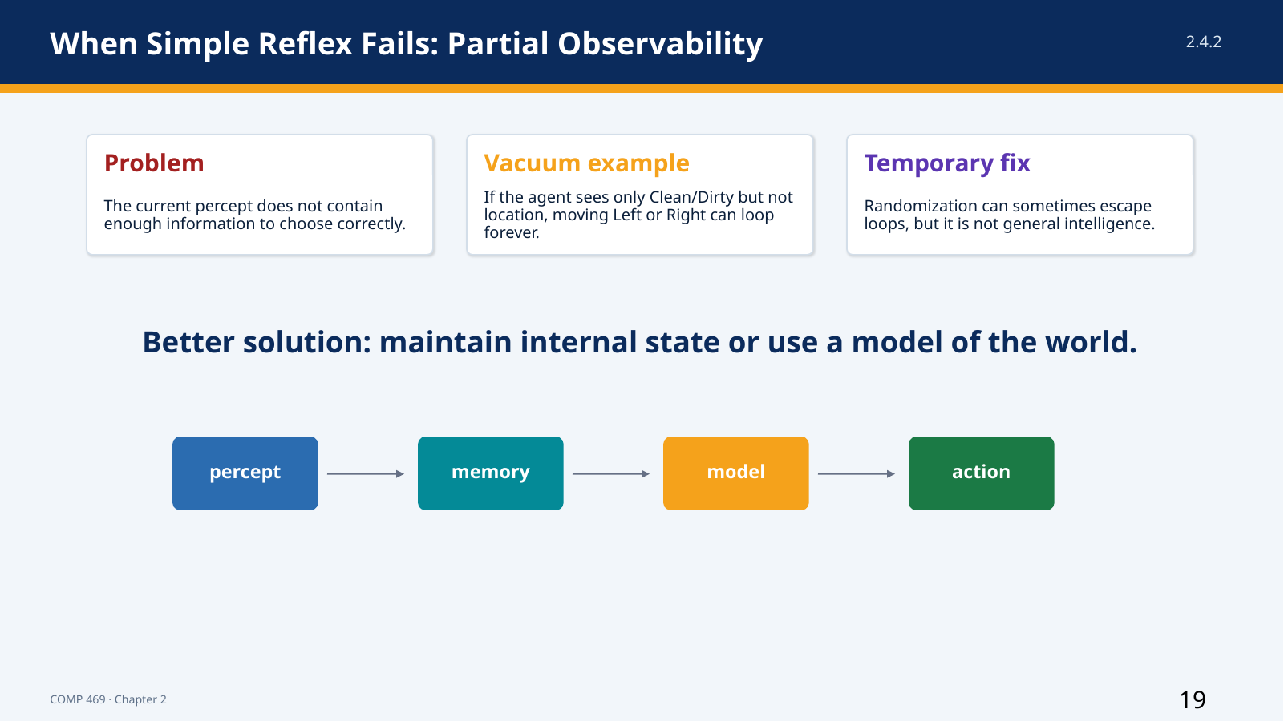 | Suggested time: 4 minutes  Teaching purpose: Section 2.4.2  Source alignment: AIMA 4e, Section 2.4.2.

Read-aloud teaching script
Suppose the vacuum agent loses its location sensor and can perceive only Clean or Dirty. The response to Dirty is still clear: Suck. The response to Clean is now ambiguous. If the agent always moves Left, it can fail forever when it starts in A. If it always moves Right, it can fail forever when it starts in B.
The problem is not a missing condition-action rule. The problem is that the current percept does not identify the relevant state. The same percept, Clean, can occur in different situations that require different actions.
Randomization can sometimes escape a loop. The vacuum might randomly choose Left or Right when it sees Clean. In this tiny environment, that may eventually reach the other square. The chapter treats randomization as a useful trick, not a general replacement for knowledge. In many tasks, random action would be inefficient or unsafe.
Pac-Man can have the same issue. If the current screen does not reveal how much frightened time remains, a reflex rule may chase a ghost when the power effect is about to end. The agent needs some representation of history or hidden state.
The more general solution is to maintain internal state—a best estimate of the parts of the world that are not directly visible now. That leads to the model-based reflex agent.
Instructor cue: Ask: what single piece of memory would fix the two-square vacuum example? Accept the last known location or a belief about location.

Transition to the next slide: Model-based agents use internal state plus models of the world and sensors.

Slide 20 — 2.4.3 Model-Based Reflex Agents
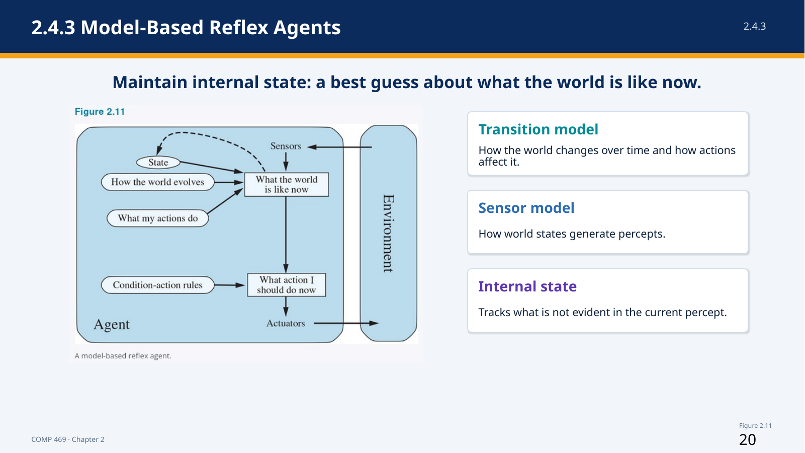 | Suggested time: 6 minutes  Teaching purpose: Section 2.4.3 and Figure 2.11  Source alignment: AIMA 4e, Section 2.4.3 and Figure 2.11.

Read-aloud teaching script
A model-based reflex agent maintains an internal state that represents its best estimate of what the world is like now. This internal state depends on the percept history, even though the program receives one current percept at a time.
Updating internal state requires two kinds of knowledge. The transition model describes how the world changes over time and how the agent’s actions affect it. If a car turns the steering wheel, the model predicts how the vehicle’s direction changes. If ghosts move after Pac-Man acts, the model predicts possible new ghost positions.
The sensor model describes how states of the world generate percepts. Brake lights in the world create illuminated regions in a camera image. A wet camera lens creates patterns that partially obscure the road. The agent uses the sensor model to interpret what a percept suggests about the underlying state.
The diagram combines the previous internal state, the last action, the transition model, the current percept, and the sensor model to produce an updated state estimate. Condition-action rules can then select an action from that estimated state.
This agent is still called reflex because the final action is selected by rules rather than explicit goal search or utility comparison. The important improvement is memory and state estimation. In a partially observable environment, the internal state may be uncertain or contain several possibilities. It is a best guess, not guaranteed ground truth.
Instructor cue: Use the driving example: a car temporarily disappears behind a truck. The internal state preserves an estimate of where the car may still be.

Transition to the next slide: The pseudocode shows exactly where state, action history, and models enter the decision loop.

Slide 21 — 2.4.3 Model-Based Reflex Agent Pseudocode
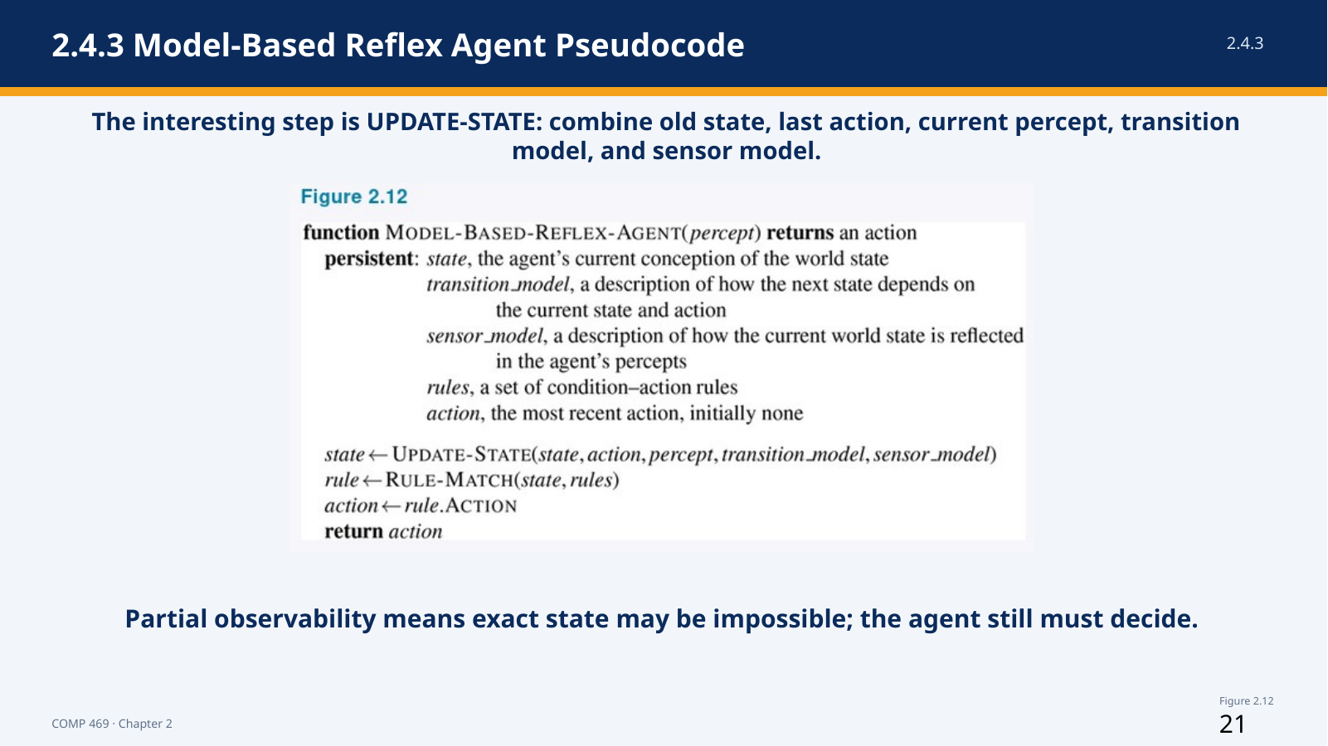 | Suggested time: 6 minutes  Teaching purpose: Section 2.4.3 and Figure 2.12  Source alignment: AIMA 4e, Section 2.4.3 and Figure 2.12.

Read-aloud teaching script
The model-based pseudocode adds persistent variables that the simple reflex agent did not have. These include state, the agent’s current conception of the world; transition model, which explains how the world changes; sensor model, which explains how states produce percepts; rules, which connect estimated states to actions; and action, the previous action taken.
The key line is UPDATE-STATE. It combines the old state, the previous action, the new percept, the transition model, and the sensor model. The result is a new internal state description.
The program then uses RULE-MATCH on that updated state, selects the rule’s action, stores the action for use during the next update, and returns it to the actuators. The previous action matters because state change depends partly on what the agent itself just did.
Notice what the program does not contain. It does not yet contain an explicit goal test or utility function. It estimates the current state and reacts according to rules. That is the difference between model-based reflex behavior and the goal-based and utility-based designs that follow.
In a real implementation, UPDATE-STATE may be simple or extremely sophisticated. It could update a few Boolean variables, track object positions, maintain probabilities over possible states, or process a learned world model. The pseudocode describes the functional role rather than requiring one specific technology.
Instructor cue: Walk through one iteration: old state, last action, new percept, updated state, matched rule, new action. Ask students which variable creates memory.

Transition to the next slide: Internal state tells the agent where it believes it is; a goal tells the agent where it wants to go.

Slide 22 — 2.4.4 Goal-Based Agents
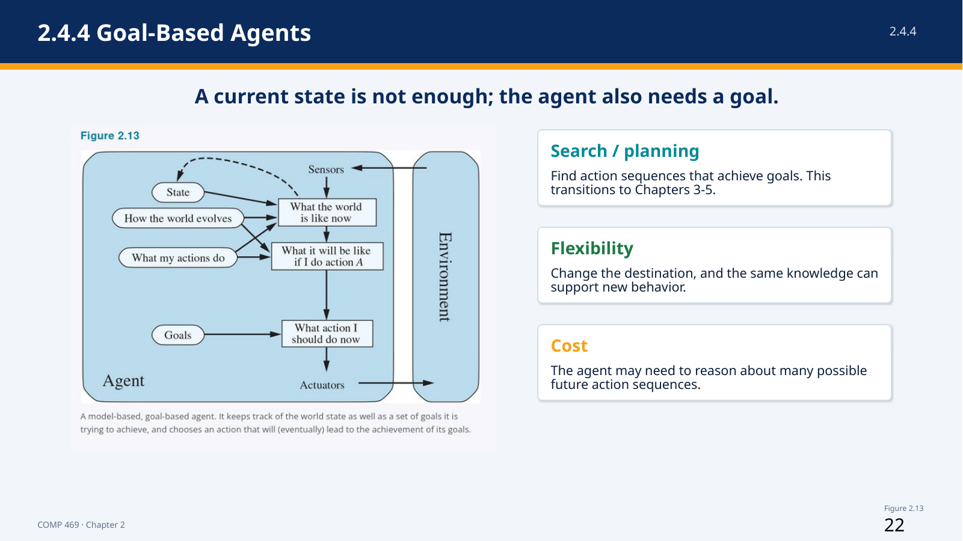 | Suggested time: 6 minutes  Teaching purpose: Section 2.4.4 and Figure 2.13  Source alignment: AIMA 4e, Section 2.4.4 and Figure 2.13.

Read-aloud teaching script
Knowing the current state is not always enough to choose an action. At an intersection, a taxi may be able to turn left, turn right, or continue straight. The correct choice depends on the destination. A goal-based agent therefore combines a state description with goal information.
The agent uses a model to predict what the world will be like after possible actions. It then asks whether those predicted states lead to the goal. When one action immediately achieves the goal, selection is simple. When the goal requires a long sequence of actions, the agent must consider alternative futures.
Search and planning are the AI subfields that find action sequences leading to goals. That is why this slide is the conceptual bridge from Chapter 2 to Chapters 3 through 5. Chapter 2 defines the goal-based architecture; the next chapters develop algorithms for searching through possible action sequences.
Goal-based decision making differs from a condition-action rule because it represents the reason for the action. A reflex agent brakes when brake lights appear because a rule fires. A goal-based agent brakes because the predicted consequence of not braking conflicts with the goal of avoiding a collision.
Goal-based agents are more flexible. Change the destination and the same model can support a new route. A reflex agent may require a new set of rules for each destination. The cost of flexibility is computation: predicting and comparing future action sequences can be expensive.
Instructor cue: Ask students to name a Pac-Man goal that requires more than one move. Then ask what state information is needed to search for it.

Transition to the next slide: The planning video makes the difference between reaction and look-ahead behavior visible.

Slide 23 — Planning Video Bridge: Reflex vs. Planning
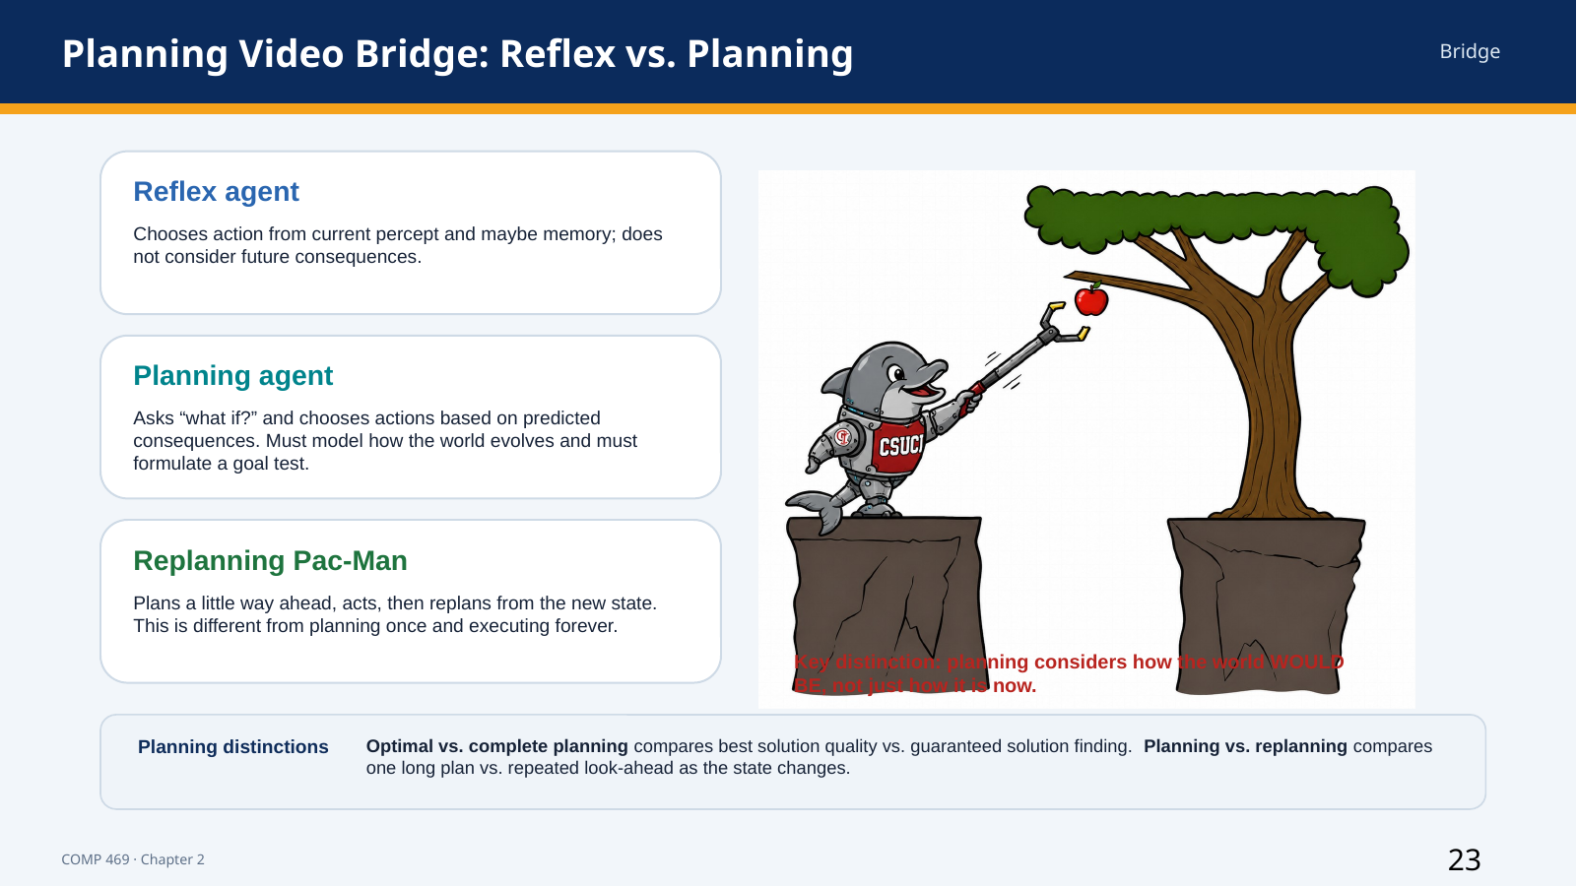 | Suggested time: 7 minutes  Teaching purpose: Goal-based agents and transition to search  Source alignment: Planning video transcript, approximately 1:19-10:05.; AIMA Chapter 2, Section 2.4.4.

Read-aloud teaching script
This slide is the bridge between Chapter 2 agent design and the next unit on search. The reflex agent chooses from the current percept, and possibly memory, but it does not explicitly evaluate future consequences. It asks, in effect, what rule applies now?
A planning agent asks a different question: what if I take this action, and then what happens after that? To answer that question, the agent needs a model of how the world evolves, a model of what its actions do, and a goal test for recognizing whether a predicted future is acceptable.
The Pac-Man examples make this distinction visible. A reflex Pac-Man may move toward an adjacent pellet because a rule fires. A planning Pac-Man can temporarily move away from a pellet if that helps it reach a better future state. Replanning means the agent looks ahead, acts, observes the new state, and plans again. That differs from computing one complete path and following it forever.
The slide also introduces two planning distinctions. Optimal planning concerns whether the agent finds the best solution according to cost or quality. Complete planning concerns whether the agent is guaranteed to find some solution if one exists. Planning versus replanning asks whether the agent commits to one long action sequence or repeatedly revises the plan as percepts change.
For this chapter, keep the boundary clear: Chapter 2 explains why a goal-based agent needs to consider future consequences. Chapter 3 explains the search algorithms that implement that look-ahead in detail.
Instructor cue: If using the video, play approximately 1:19-10:05. Ask students to identify where the agent stops reacting only to the current percept and begins evaluating future states.

Transition to the next slide: Goals tell the agent what counts as success, but they do not rank multiple successful outcomes. Utility provides that ranking.

Slide 24 — 2.4.5 Utility-Based Agents
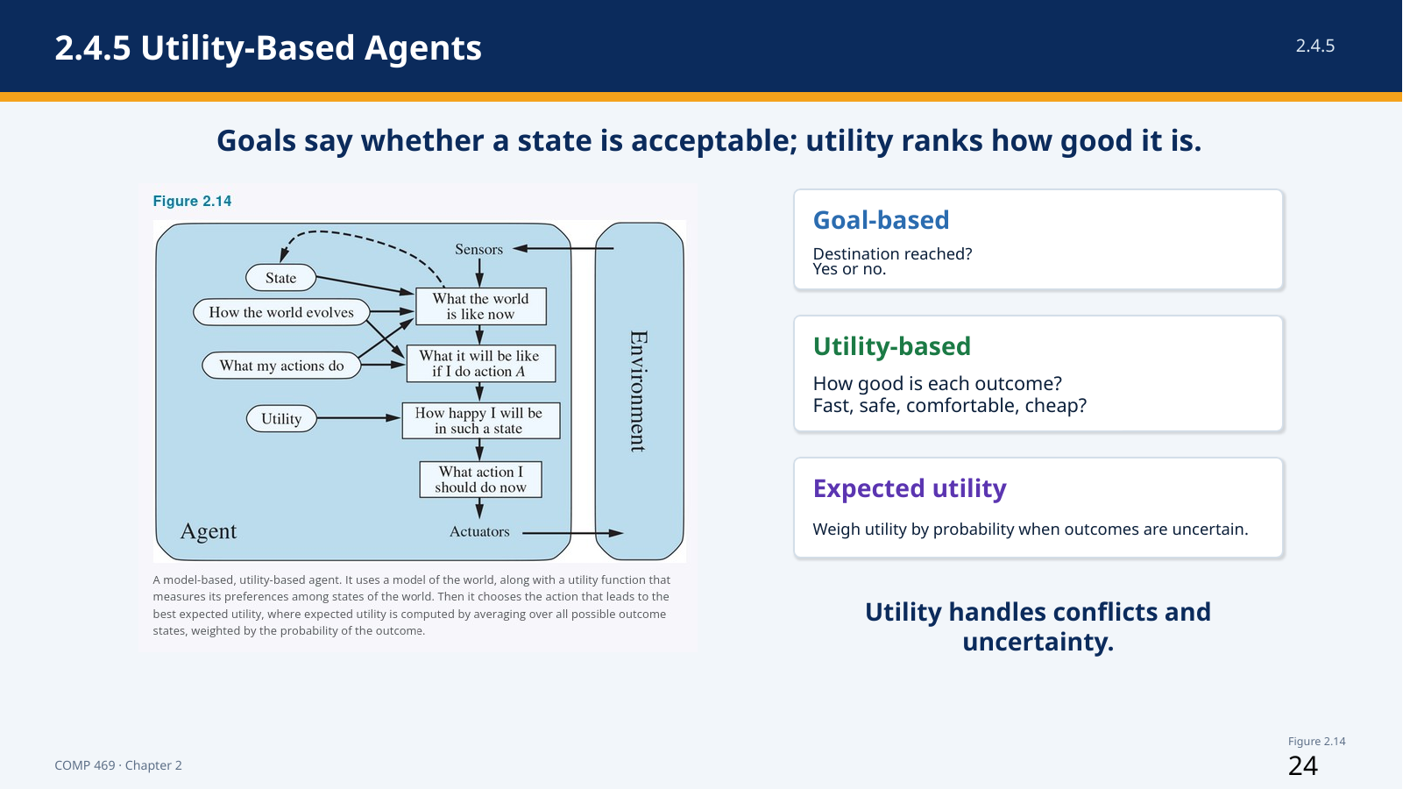 | Suggested time: 6 minutes  Teaching purpose: Section 2.4.5 and Figure 2.14  Source alignment: AIMA 4e, Section 2.4.5 and Figure 2.14.

Read-aloud teaching script
A goal usually gives a binary distinction: the destination is reached or it is not. In most environments, that is not enough to produce high-quality behavior. Many routes may reach the same destination, but they differ in safety, speed, cost, comfort, reliability, and energy use.
A utility function assigns a degree of desirability to outcomes. The agent predicts possible future states, evaluates how desirable those states are, and chooses an action that leads to the best expected result.
The chapter describes the utility function as an internalization of the performance measure. The performance measure is the external standard used to evaluate the agent. The utility function is the agent’s internal representation of how desirable outcomes are. When the two agree, maximizing utility supports rational behavior according to the external standard.
Utility is especially useful in two situations. First, goals may conflict. A taxi may need to trade speed against safety or comfort against cost. Second, outcomes may be uncertain. No action may guarantee success, so the agent must weigh both the value and probability of each possible outcome.
A utility-based agent is not automatically simple. It still needs perception, state estimation, a model of possible outcomes, and an algorithm for comparing choices. The utility function makes the decision criterion explicit; it does not remove the computational difficulty.
Instructor cue: Use two routes to the same destination: one fast but risky, one slower but safer. Ask why a goal test cannot choose between them.

Transition to the next slide: The next slide focuses on the two main reasons utility is more expressive than goals: tradeoffs and uncertainty.

Slide 25 — Utility Handles Tradeoffs and Uncertainty
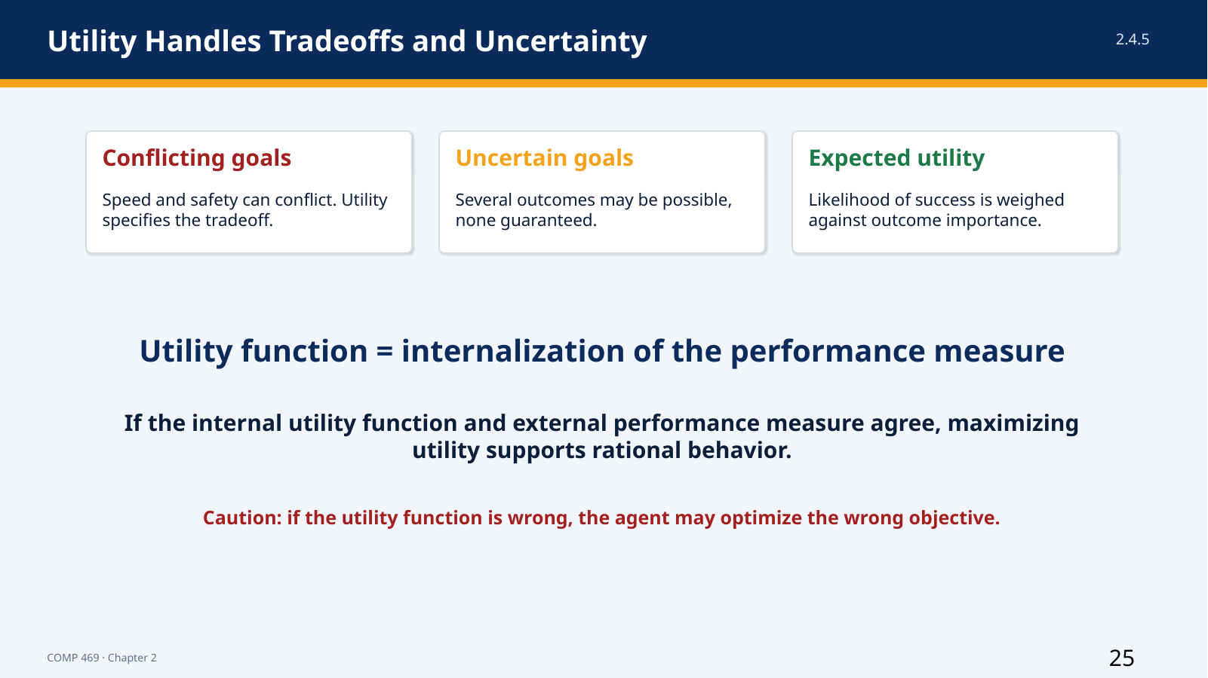 | Suggested time: 5 minutes  Teaching purpose: Section 2.4.5  Source alignment: AIMA 4e, Section 2.4.5.

Read-aloud teaching script
Utility provides a common scale for comparing outcomes that satisfy different goals to different degrees. When speed and safety conflict, a utility function specifies how much one is worth relative to the other. When several outcomes are possible, expected utility combines each outcome’s value with its probability.
Expected utility does not mean that the agent always receives the outcome with the highest utility. It means the agent chooses the action with the best probability-weighted average according to its model. A rational decision can still produce an unfortunate result because uncertainty remains.
In Pac-Man, an agent might compare an action that safely reaches one pellet with an action that could reach a power pellet and several ghosts but carries a greater risk of being caught. A utility function can assign values to score, survival, completion, and risk. The selected action depends on those values and the estimated probabilities.
The major caution is alignment. If the internal utility function does not match the external performance measure, the agent may optimize the wrong objective. Utility-based behavior is powerful because it is general; that same generality makes correct objective specification essential.
The chapter also notes that perfect rationality is usually computationally unattainable. Even when a utility function is correct, the agent may not have enough time or processing power to evaluate every possible action sequence. Practical agents approximate the best decision under resource limits.
Instructor cue: Ask whether maximizing score alone is a sufficient Pac-Man utility. Encourage students to identify survival and task completion as additional terms.

Transition to the next slide: So far, every design assumes that the agent’s rules, models, goals, or utility already exist. Learning explains how those components can improve.

Slide 26 — 2.4.6 Learning Agents
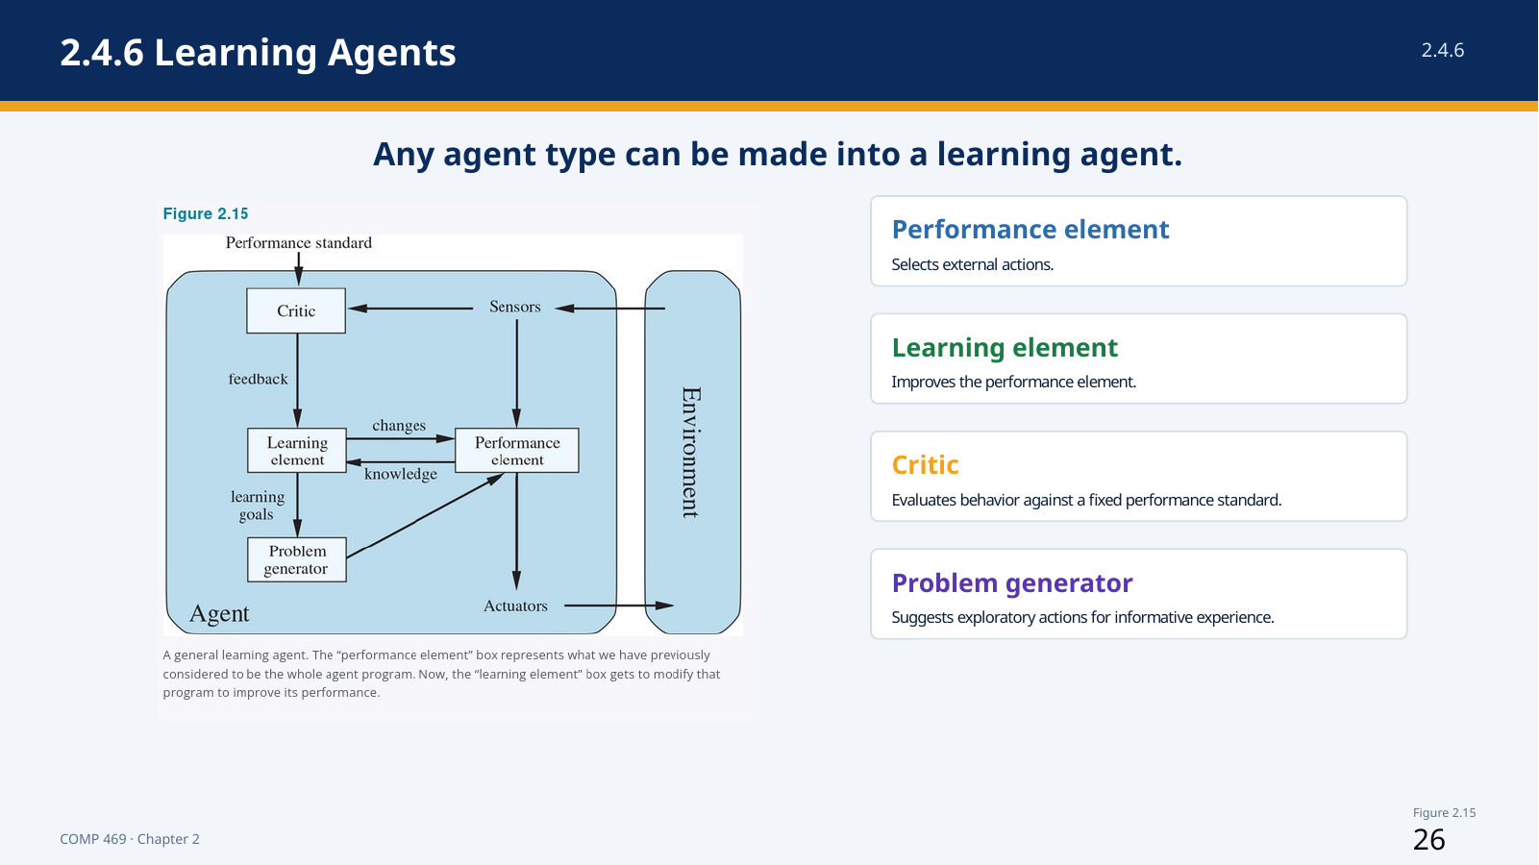 | Suggested time: 7 minutes  Teaching purpose: Section 2.4.6 and Figure 2.15  Source alignment: AIMA 4e, Section 2.4.6 and Figure 2.15.

Read-aloud teaching script
Any of the agent types we have discussed can be built as a learning agent. Learning is not a separate alternative that replaces reflex, model-based, goal-based, or utility-based design. It is a way for the components of those agents to improve through experience.
The chapter divides a learning agent into four conceptual components. The performance element selects external actions. It is the part we previously treated as the entire agent. The learning element modifies the performance element so that future behavior improves.
The critic evaluates how well the agent is doing relative to a fixed performance standard. Percepts alone do not automatically tell the agent whether an outcome is good. A chess program may perceive checkmate, but the critic and performance standard identify that result as success or failure.
The problem generator suggests exploratory actions that may produce informative experience. If the performance element always chooses the best-known action, the agent may never discover a better alternative. Exploration can reduce short-term performance while improving long-term knowledge.
Turing argued that programming every intelligent behavior by hand would be too slow and that learning machines should instead be taught. The same motivation applies here. Learning allows the agent to operate in unknown environments, correct inaccurate prior assumptions, and become more competent than its initial programming alone would allow.
Instructor cue: Point to each box in Figure 2.15 and have students repeat the role: performance acts, critic evaluates, learning improves, problem generator explores.

Transition to the next slide: The next slide asks exactly which internal components a learning process can modify.

Slide 27 — Learning Agent Components: What Improves?
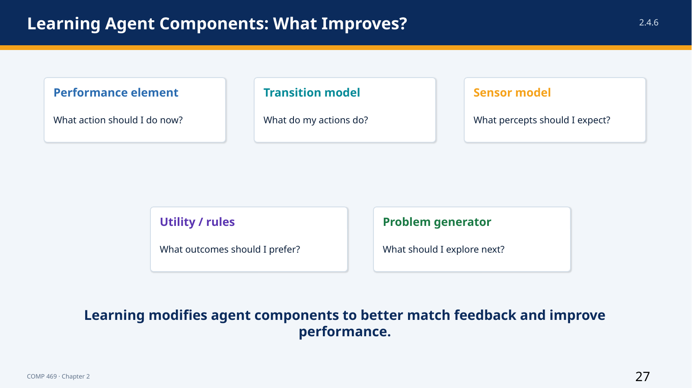 | Suggested time: 6 minutes  Teaching purpose: Section 2.4.6  Source alignment: AIMA 4e, Section 2.4.6.

Read-aloud teaching script
The design of the learning element depends on the performance element. Before asking how an agent will learn, we should ask what mechanism will select actions after learning has occurred. Learning can then improve the components used by that mechanism.
The agent can learn a transition model by observing how states change after actions. An automated taxi can learn how braking pressure affects deceleration on wet pavement. The agent can improve a sensor model by learning how conditions such as glare, rain, or occlusion affect observations.
It can learn condition-action rules, a policy, a utility function, or parameters used by the performance element. Feedback from the critic identifies which changes improve performance. The performance standard should remain fixed conceptually; otherwise, the agent could improve its apparent score by changing the standard rather than improving its behavior.
The problem generator supports exploration. It identifies uncertain or poorly understood parts of the model and proposes actions that produce useful evidence. This is similar to an experiment: the immediate action may not be valuable for the task, but the information gained can improve future decisions.
The unifying idea is modification. Learning brings the agent’s internal components into closer agreement with available feedback and with the actual environment. A system may learn one component while other components remain hand-designed.
Instructor cue: Use the taxi-tip example: if rough driving produces fewer tips, the critic must connect that feedback to the performance standard before the agent can learn a smoother policy.

Transition to the next slide: Learning and reasoning both depend on how the agent represents states, attributes, objects, and relationships.

Slide 28 — 2.4.7 Representing the World Inside the Agent
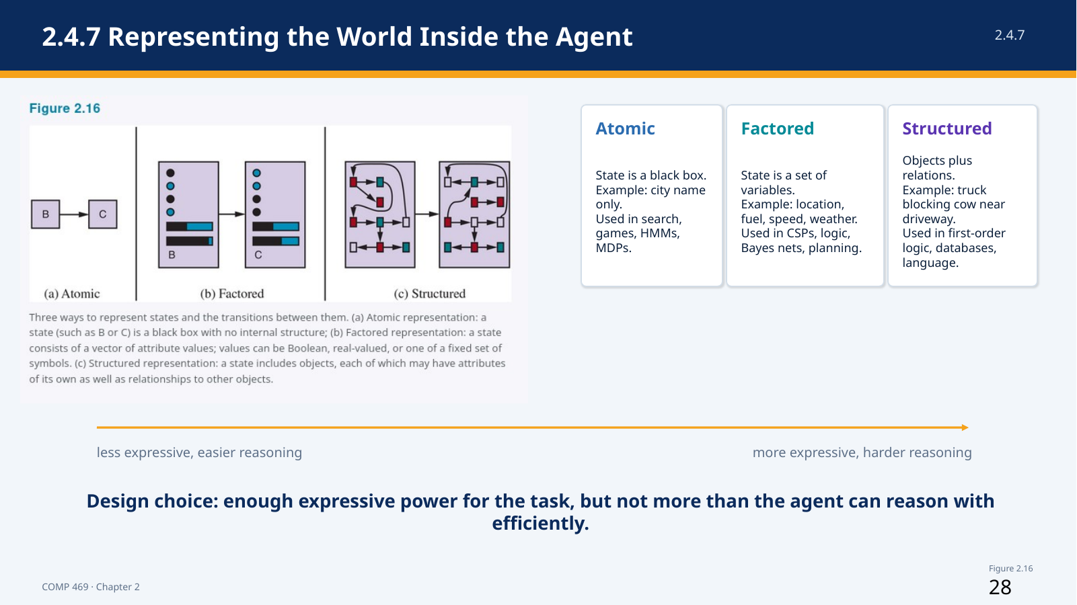 | Suggested time: 7 minutes  Teaching purpose: Section 2.4.7 and Figure 2.16  Source alignment: AIMA 4e, Section 2.4.7 and Figure 2.16.

Read-aloud teaching script
Chapter 2 closes by comparing three levels of representation: atomic, factored, and structured. These are not agent types. They describe how agent components represent states and relationships in the environment.
In an atomic representation, each state is an indivisible label. A route-planning state might be represented only by the current city. The system can distinguish Arad from Bucharest, but the state itself has no internal attributes. Search, game-playing, hidden Markov models, and Markov decision processes often use atomic states.
In a factored representation, a state is a collection of variables and values. A driving state might include location, fuel level, speed, weather, warning lights, and available money for tolls. Two states can share some attributes while differing in others. Constraint satisfaction, propositional logic, planning, Bayesian networks, and many machine-learning methods use factored representations.
In a structured representation, the system represents objects and relationships explicitly. Instead of one giant variable describing a truck, cow, road, and driveway situation, the representation contains separate objects and relations among them. First-order logic, relational databases, and much of natural-language understanding rely on structured representations.
More expressive representations can describe complex situations more naturally and concisely, but reasoning and learning usually become more difficult. The design goal is not maximum expressiveness; it is enough expressive power for the task while remaining computationally manageable. The chapter also notes that concepts can be stored locally or distributed across many memory locations, an idea that becomes important later in neural representations.
Instructor cue: Ask students to represent the same Pac-Man state atomically, then factored. A structured version can represent Pac-Man, ghosts, pellets, and spatial relationships as objects and relations.

Transition to the next slide: We can now compare all of the agent program designs in one view.

Slide 29 — All Agent Program Designs in Chapter 2
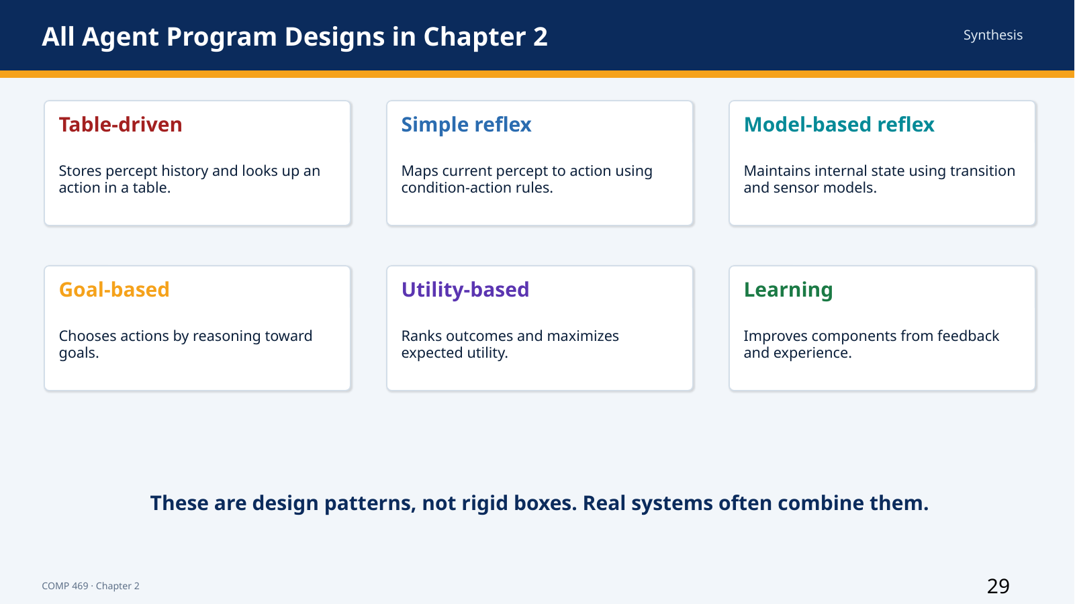 | Suggested time: 5 minutes  Teaching purpose: Synthesis of Sections 2.4.1-2.4.6  Source alignment: AIMA 4e, Sections 2.4.1-2.4.6.

Read-aloud teaching script
This slide is a checkpoint covering every agent design presented in the lecture. The table-driven agent stores the percept history and looks up an action. It represents the complete agent function explicitly but does not scale.
The simple reflex agent maps the current percept-derived state directly to an action using condition-action rules. It is compact and fast but depends on sufficient observability.
The model-based reflex agent maintains internal state using a transition model and sensor model, then applies rules to the estimated current state. It is designed for partial observability.
The goal-based agent adds a goal and predicts future states to find an action sequence that reaches that goal. Search and planning provide the mechanisms for this look-ahead behavior.
The utility-based agent ranks outcomes and chooses the action with the highest expected utility. It supports tradeoffs and uncertainty when a binary goal is not enough.
The learning agent improves components through feedback and exploration. Learning can be added to any of the other designs. A model-based utility agent can learn its transition model; a reflex agent can learn rules; a goal-based agent can learn better search guidance.
These are design patterns, not rigid boxes. Real systems commonly combine them. The most useful classification is the one that explains what information the system represents and how it selects actions.
Instructor cue: Ask students to compare adjacent rows: what new information is added when moving from simple reflex to model-based, from model-based to goal-based, and from goal-based to utility-based?

Transition to the next slide: The environment properties tell us which of these design capabilities are necessary.

Slide 30 — Choosing an Agent Design from Environment Properties
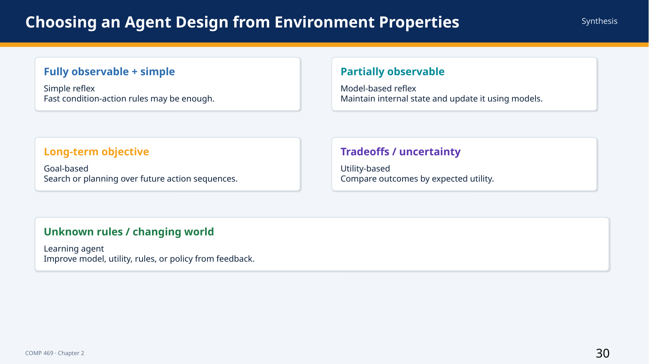 | Suggested time: 6 minutes  Teaching purpose: Synthesis of Sections 2.3 and 2.4  Source alignment: AIMA 4e, Sections 2.3 and 2.4.

Read-aloud teaching script
The practical design rule is to let the task environment drive the agent architecture. In a fully observable, simple environment, a simple reflex agent may be sufficient. There is no benefit in building a complex planner when a reliable current-state rule produces the correct action.
Partial observability creates a need for memory and state estimation, which points toward a model-based agent. A long-term objective that requires a sequence of actions creates a need for goals, prediction, search, or planning.
When several successful outcomes differ in quality, or when outcomes are uncertain, utility provides a way to compare them. When the rules, models, environment, or performance measure are unknown or changing, learning becomes necessary.
These choices are cumulative rather than exclusive. A self-driving system may be model-based because it tracks hidden state, goal-based because it navigates to a destination, utility-based because it balances safety and travel time, and learning-based because it improves perception and prediction from data. It may also contain simple reflex safety rules for immediate braking.
A disciplined design process therefore follows four steps. First, define the agent and environment. Second, specify PEAS. Third, classify the environment. Fourth, select the least complex agent design that can represent the required information and make adequate decisions.
Instructor cue: Give one environment description and ask the class to select a design. Example: a thermostat is fully observable enough, single-agent, simple, and dynamic; a reflex or control policy may be sufficient.

Transition to the next slide: The PEAS activity lets students apply this workflow before proposing an algorithm.

Slide 31 — Class Activity: Build a PEAS Description
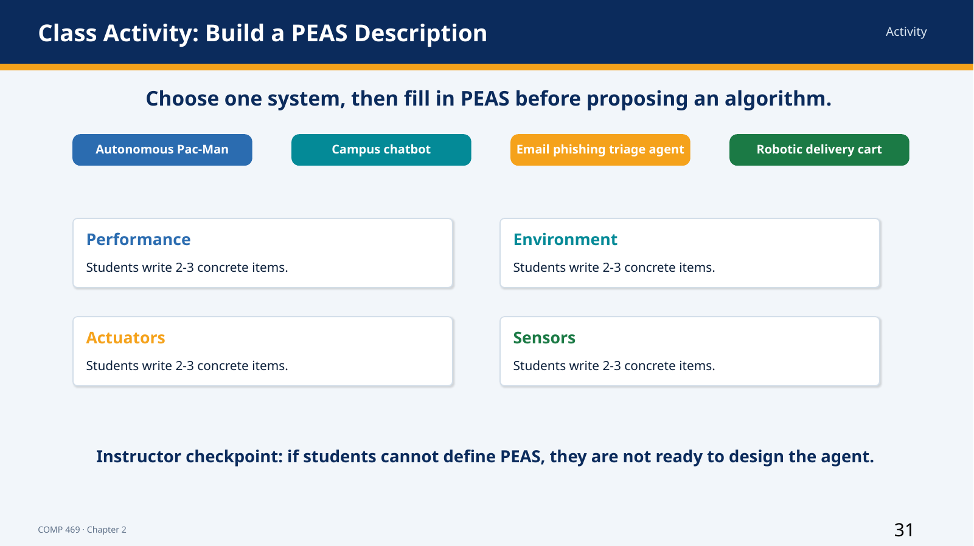 | Suggested time: 12 minutes  Teaching purpose: Applied Section 2.3.1  Source alignment: AIMA 4e, Section 2.3.1; lecture deck activity.

Read-aloud teaching script
We are going to pause the lecture and specify a task before discussing an implementation. Each group will choose one system: autonomous Pac-Man, a campus chatbot, an email phishing triage agent, or a robotic delivery cart.
Your group must write at least two concrete items for each PEAS category. For Performance, avoid vague words such as ‘good’ or ‘smart.’ State what successful behavior means and identify at least one failure or cost. For Environment, identify the entities and conditions the agent must handle. For Actuators, list the outputs or actions that can change the environment. For Sensors, list the information the agent can actually receive.
After PEAS, classify the environment on at least three dimensions and recommend an agent design. Be prepared to explain why the design matches the environment. You have approximately eight minutes, followed by short reports.
As you work, remember that an algorithm cannot compensate for missing task specification. If the performance measure is unclear, there is no objective definition of rational behavior. If the sensors cannot provide relevant information, the agent may need memory, a model, exploration, or a redesigned architecture.
When groups report, listen for mismatches. A chatbot that can only display text cannot directly reset an account unless an actuator or integration provides that capability. A phishing triage system cannot inspect attachment behavior if the sensors provide only the subject line. A delivery cart expected to operate in rain needs sensors and environmental assumptions that support that requirement.
Instructor cue: Activity flow: 1 minute setup, 8 minutes group work, 3 minutes reports. Instructor answer prompts: Pac-Man—score/survival, maze, moves, game state; chatbot—accuracy/resolution, users/systems, response/escalation, prompts/context; phishing—detection/false positives, mail environment, label/quarantine/alert, headers/body/links/attachments; cart—safe timely delivery, campus paths/people/weather, motors/brakes/signals, camera/lidar/GPS.

Transition to the next slide: We will now apply the same vocabulary to the autonomous Pac-Man program used in the class demonstration.

Slide 32 — Class Demo: Autonomous Pac-Man Agent
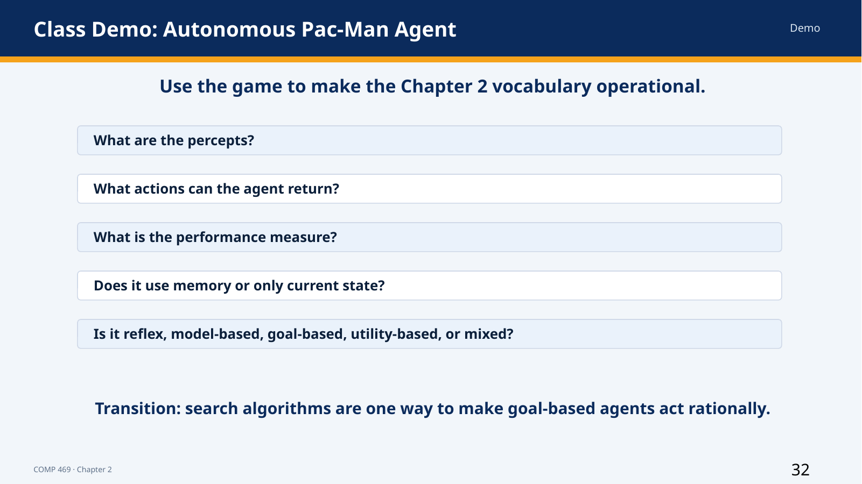 | Suggested time: 10 minutes  Teaching purpose: Applied Sections 2.1-2.4.6  Source alignment: AIMA 4e, Sections 2.1-2.4.6; autonomous Pac-Man classroom code.

Read-aloud teaching script
As the game runs, do not evaluate it only by whether Pac-Man wins. Identify the agent design. The environment is the maze with walls, pellets, power pellets, ghosts, and scoring rules. The percept supplied to the program includes position, legal moves, remaining pellets, power-pellet state, and ghost information.
The actuators are the movement actions returned by the program. Each action changes the state and produces a new percept. The performance measure includes score, survival, and completion. If the program chooses the action with the highest calculated value, it has a utility-based component. If it searches paths to pellets, it has a goal-based component. If it tracks timers or ghost release state, it has a model-based component.
Watch for the power pellet. A normal pellet changes the score only. A power pellet changes the environment by placing ghosts into a frightened state for a limited time. If the agent tracks the remaining duration, that information becomes internal state. During frightened mode, the utility of approaching a ghost changes from strongly negative to positive.
Ask whether the agent is rational. The answer depends on the performance measure and the information available. A locally reasonable move can still lead to a poor later outcome if the agent has a short planning horizon. A system can therefore be rational relative to a limited model while remaining less capable than a more complete planner.
This demonstration illustrates why the textbook categories can overlap in real code. The program does not need to fit one pure box. The categories help us identify which information is explicit and which decision mechanism is being used.
After this vocabulary mapping, the next slide identifies the live code files. The point of the live demo is not to teach Pygame. The point is to show that the visual environment can remain fixed while the agent program changes. That separation reinforces the Chapter 2 formula: agent equals architecture plus program.
Instructor cue: Pause the program at least twice. Ask students to predict the selected action and justify it using percepts, goal, utility, or internal state. Restart once to show that changing ghost behavior can change outcomes.

Transition to the next slide: Next, we will connect the live Pac-Man behavior to the specific Python agent files that implement the Chapter 2 agent designs.

Slide 33 — Live Code Demo: Five Chapter 2 Agent Programs
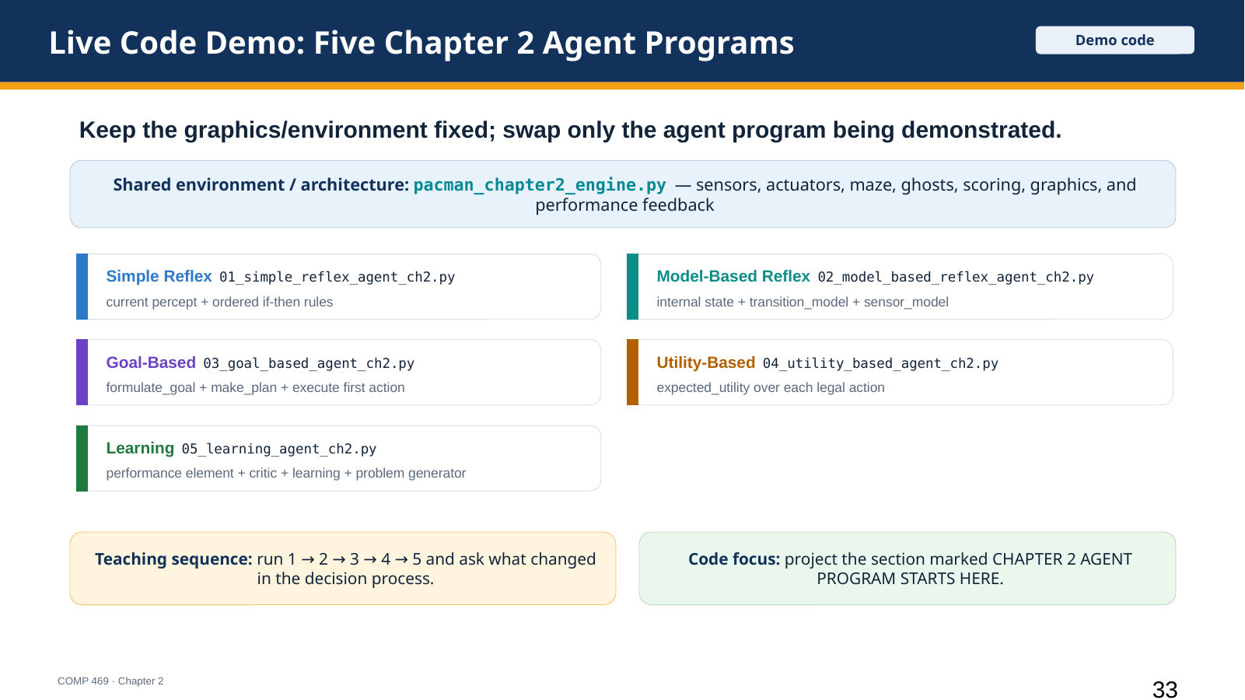 | Suggested time: 10 minutes  Teaching purpose: Live demonstration files; Section 2.4 agent program designs  Source alignment: Uploaded files: pacman_chapter2_engine.py and 01-05 *_agent_ch2.py.; AIMA Chapter 2, Sections 2.4.1-2.4.6.

Read-aloud teaching script
This slide identifies the code we will use for the live demonstration. The shared file, pacman_chapter2_engine.py, represents the environment and architecture. It handles the maze, graphics, sensors, actuators, ghosts, scoring, and performance feedback. We are not studying that file first because it is support code for the classroom display.
The important instructional point is that the environment remains fixed while the agent program changes. Each numbered file contains one Chapter 2 agent program. Project the section marked CHAPTER 2 AGENT PROGRAM STARTS HERE, then run the file so students can connect the code to the visible behavior.
Start with 01_simple_reflex_agent_ch2.py. Point out that the decision method receives only the current percept and applies ordered condition-action rules. It has no memory, model, goal, utility function, or learning component.
Then use 02_model_based_reflex_agent_ch2.py. Show the InternalState structure and the transition_model, sensor_model, update_state, and choose_action methods. This agent still fires reflex rules, but those rules operate on an updated internal state instead of the current percept alone.
Next use 03_goal_based_agent_ch2.py. Show formulate_goal, make_plan, and choose_action. The agent selects a desired future state, creates an action sequence, and executes the first step. Treat the path-planning helper as a black box for now; the search algorithm itself belongs to Chapter 3.
Then use 04_utility_based_agent_ch2.py. Show expected_utility and choose_action. This agent does not commit to a single stored plan. It evaluates legal actions by expected desirability, including food reward, movement cost, and ghost risk, then chooses the action with maximum expected utility.
Finally use 05_learning_agent_ch2.py. Show the four Chapter 2 learning-agent components: performance_element, learning_element, critic, and problem_generator. The performance element chooses actions; the critic supplies feedback; the learning element modifies future preferences; and the problem generator encourages exploration.
The teaching sequence is one through five. After each run, ask the same question: what information did this agent use that the previous one did not? That comparison keeps the demonstration anchored in Chapter 2 rather than turning it into a programming exercise.
Instructor cue: Run the files in order. Keep the engine file closed unless students ask about sensors or actuators. The code section to project is the agent class in each numbered file.

Transition to the next slide: After the code demonstration, we will return to the planning video boundary and separate Chapter 2 concepts from Chapter 3 algorithms.

Slide 34 — How the Planning Video Fits Your Lecture
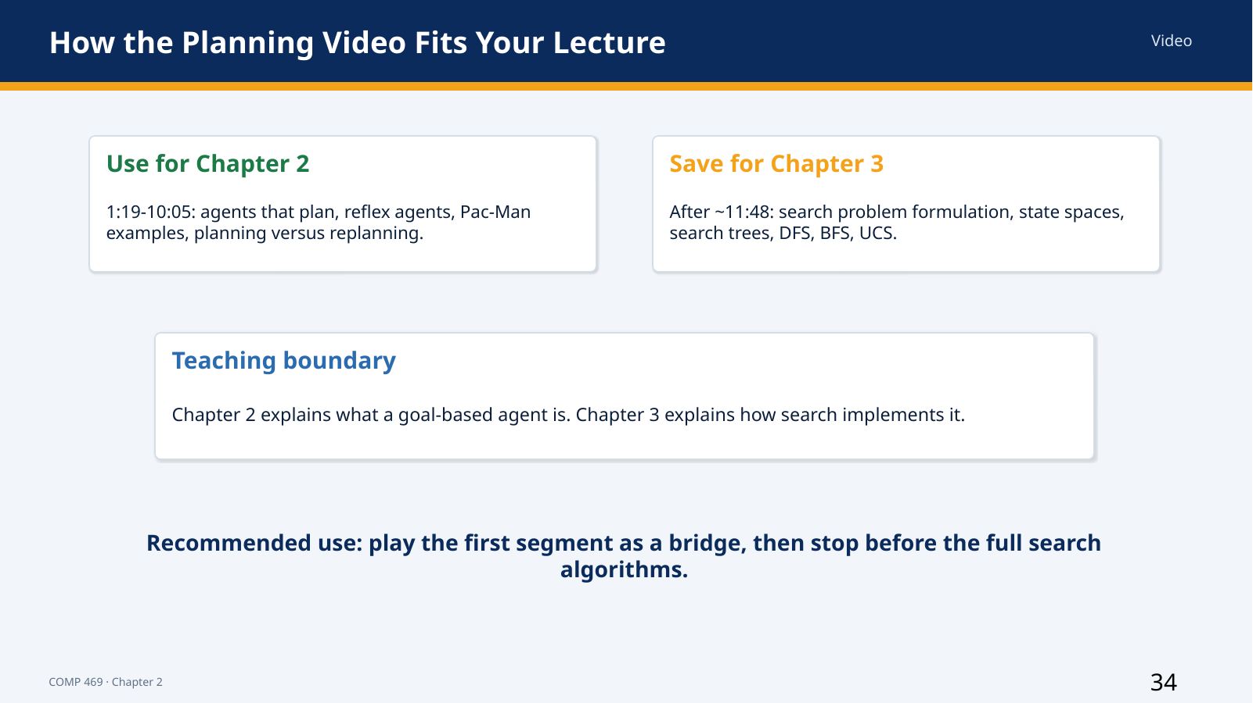 | Suggested time: 2 minutes  Teaching purpose: Chapter boundary and course sequencing  Source alignment: Planning video transcript, approximately 1:19 onward.; AIMA 4e, Section 2.4.4.

Read-aloud teaching script
This slide establishes the boundary between the current chapter and the next unit. The first portion of the planning video belongs here because it compares reflex agents with agents that predict future consequences. The Pac-Man demonstrations show why local condition-action rules can fail and why a goal-based agent may need to plan or replan.
After approximately eleven minutes, the lecture begins formal search problem formulation: state spaces, start states, successor functions, goal tests, search trees, depth-first search, breadth-first search, and uniform-cost search. Those topics belong to Chapter 3.
The conceptual sequence is simple. Chapter 2 explains what a goal-based agent needs: a state, a model of action consequences, and a goal. Chapter 3 explains how search can compute an action sequence that reaches that goal. Keeping the boundary clear prevents the agent architecture and the search algorithm from being treated as the same concept.
Instructor cue: Instructor pacing note: play the early segment during this lecture and save the full search material for the next deck.

Transition to the next slide: We will close by compressing the chapter into a small set of design rules.

Slide 35 — Chapter 2 Takeaways
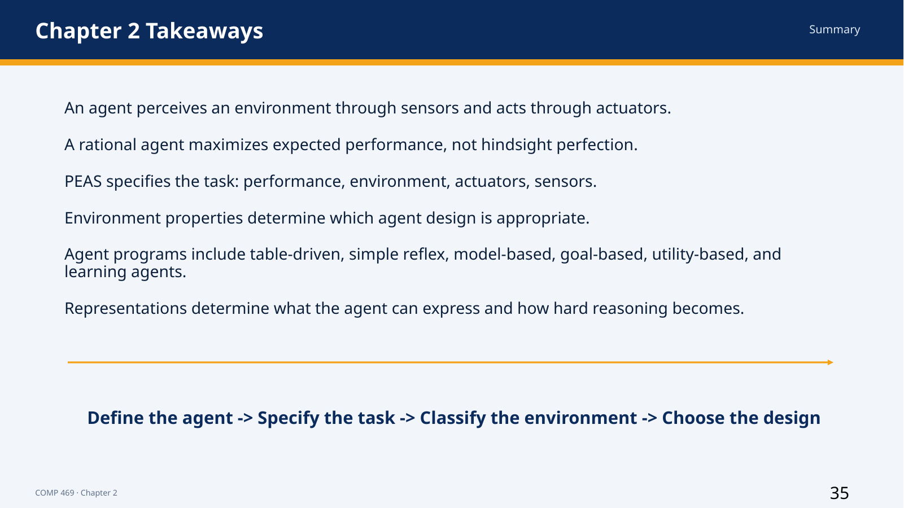 | Suggested time: 4 minutes  Teaching purpose: Chapter summary  Source alignment: AIMA 4e, Chapter 2 summary.

Read-aloud teaching script
Chapter 2 presents AI as the science and engineering of agent design. An agent perceives an environment through sensors and acts through actuators. The agent function maps percept sequences to actions, while the agent program implements that mapping on an architecture.
A rational agent chooses the action expected to maximize its performance measure, given its prior knowledge, available actions, and percept sequence. Rationality is not omniscience or hindsight perfection. Information gathering, learning, and autonomy can all be rational because they improve later decisions.
PEAS specifies the task through Performance measure, Environment, Actuators, and Sensors. Environment dimensions—observability, number of agents, determinism, episodic or sequential structure, static or dynamic behavior, discrete or continuous state, and known or unknown rules—guide the design.
The table-driven agent is a conceptual baseline but does not scale. Simple reflex agents use current-percept rules. Model-based reflex agents maintain internal state. Goal-based agents predict futures that achieve goals. Utility-based agents compare outcomes and uncertainty. Learning agents improve components through feedback and exploration.
Finally, internal representations can be atomic, factored, or structured. More expressive representations describe richer worlds but usually require more complex reasoning.
The complete workflow is: define the agent, specify the task, classify the environment, and choose the design. The next unit begins with goal-based agents and develops search algorithms for finding action sequences.
Instructor cue: Closing retrieval check: ask students to define PEAS, name the six agent designs covered in the deck, and explain one environment property that forces a more capable agent design.

Live Demo Setup Notes
- Keep pacman_chapter2_engine.py in the same directory as all five agent files. The engine represents the environment, architecture, sensors, actuators, scoring, and graphics.
- Project the numbered agent file being demonstrated, not the engine file. The code section marked CHAPTER 2 AGENT PROGRAM STARTS HERE is the instructional focus.
- Run the demonstrations in this order: simple reflex, model-based reflex, goal-based, utility-based, learning.
- After each run, ask what information the agent used: current percept only, internal state, explicit goal, expected utility, or feedback-driven improvement.
- For the learning agent, use the built-in training control only after students have seen the untrained behavior.

